University of Brighton
Computer Games

CI541 - Game Development Frameworks 2025-6
Module Leader: David Dorrington



Coursework: Unreal Project
Student: Finley Nye
Date Submitted:

Student Declaration for AI
I declare that my use of Generative AI tools is permitted under the assignment’s RAG rating (amber or green). Where appropriate I have checked the accuracy and bias of any outputs generated by Generative AI tools. By submitting this assignment, I acknowledge that I am responsible for any work presented.
I acknowledge use of Generative AI tools in the following areas:
Area where generative AI has been used  See example activities in each area on BSSH website | What tool did you use and what did you use it for? Include prompts if required by your assessment brief  Example: Preparation – Used Copilot to get ideas of suitable report structures. Prompt : “I am a third year undergraduate student in the UK, suggest a suitable outline structure for a research project report”
Assessment planning  e.g. time management | Used ChatGPT to help structure the report and organise sections.  Prompt: “Help me refine a clear structure for a university game development report including technical systems and an evaluation”.
Preparation  e.g. explaining terminology, exploring background | Used ChatGPT to clarify terminology and concepts related to game design and Unreal Engine systems.  “explain player feedback systems in games and how they improve user experience”.
Research, note taking and organising ideas  Eg initial research, explaining source material | Used ChatGPT to help identify relevant sources and understand how to apply them to my project.  Prompt: “what are the key principles of environmental puzzle design in games?”.
Writing  e.g. drafting, transforming content | Used ChatGPT to help rephrase and improve clarity of written sections whilst retaining original ideas.  “Rewrite this paragraph to sound more academic, whilst keeping the same meaning”.
Editing and revision  Eg feedback on structure | Used ChatGPT to review sections and suggest improvements.  Prompt: “Give feedback on this section of my report and suggest improvements”.
Proofreading  e.g. correct spelling and grammar | Used ChatGPT to correct spelling, grammar and sentence clarity.  Prompt: “Check this section for grammar mistakes and improve readability”.
Calculations, data handling and coding  e.g. analysis of data | Used ChatGPT for general blueprint logic queries and to understand system implementation.  Prompt: “how do I fix a physics handle jitter issue in Unreal Engine?”.
Creation of visuals  e.g. image generation | Used ChatGPT for guidance on structuring diagrams and selecting appropriate visuals (no direct image generation in final report).
Other
Anything that does not fit in the areas above

All final content was reviewed and edited manually to ensure accuracy and alignment with the project.

Contents

Student Declaration for AI 1
Contents 3
Introduction 3
Game Development Focus 4
Game Idea 5
Game Design Decisions 6
Game Flow & Events 6
Level Map 8
Other Relevant Planning 9
Technical Development Areas 10
Area 1: Physics Interaction System 11
Area 2: Player Feedback and Interaction Feedback System 15
Area 3: Environmental Puzzle Design 15
Testing and Problems 15
Problems 15
Critical Review 15
Conclusion 15
References 15
Bibliography 15
Appendices 15
Walkthrough and Cheats 15
Game Assets 15

Introduction
Working Title: Industrial Ascent
Industrial Ascent is a First Person physics based game in which the player must manipulate physical objects in the environment to progress through a confined industrial space. Using a gravity manipulation tool, the player can pick up, rotate (both freely and in finer increments), freeze and throw objects to overcome obstacles.
Progression is achieved through the creative use of environmental assets, requiring the player to construct pathways, bridge gaps and interact with the more dynamic elements like NPCs or explosive or breakable objects. The current objective of the prototype is to escape the level by solving a sequence of the interconnected environmental puzzles.

Game Development Focus
The primary technical focus of this project is the development of a physics driven interaction system that enables the player to directly manipulate objects within the environment. This is achieved though the implementation of a gravity gun mechanic which is supported by realistic physics behaviour and responsive feedback systems. These elements work together to create an intuitive experience, allowing the player to experiment with object placement, movement and environmental interaction. By combining the precise control with believable physical response, the system encourages creative problem solving and supports the design of multi stage environmental puzzles that build upon the same core mechanics.
 | Game Development Area | Gameplay Usage | Intended Experiential Result
1 | Gravity Gun System | Grab, Rotate, Freeze and throw objects. | Player feels control and precision
2 | Physics Based Interaction | Objects that respond realistically to movement and forces. | Creates believability and consistency
3 | Environmental Puzzle Design | Objects that are used to form paths and solve traversal challenges. | Encourages creativity and problem solving.
4 | Player Feedback Systems | Visual, Physical and diegetic feedback from physical interaction | Reinforces the player understanding and interaction clarity.

Game Idea
Industrial Ascent is a first person puzzle experience set within an industrial shipping container environment. The player is equipped with a gravity manipulation tool that allows them to interact with the objects in the world to solve spatial challenges.
The gameplay is centred around constructing paths, manipulating the environmental elements, and overcoming traversal obstacles using creative physics based mechanics. Rather than following a single predefined solution, players are encouraged to experiment with the available tools to discover their own approaches to each puzzle. The goal is to navigate through the environment and escape the level.

Game Design Decisions
Element | Details
Working title | Industrial Ascent
Concept | Physics Based puzzle game using environmental manipulation
Genre | First Person Puzzle
Theme | Industrial / Mechanical / utilitarian
Design Pillars | Interaction, Creativity, Spatial Problem Solving
Player Experiences | Discovery, Experimentation, satisfaction from emergent solutions
Overall Goal of Game | Escape the level by solving environmental puzzles
Core Gameplay | Grab -> Rotate -> Place -> Traverse
Main Gameplay Challenges | Object Placement, vertical traversal, environmental hazards
World Information | Confined Industrial yard constructed from shipping containers and structural elements
Environment Style | Shipping Containers, industrial structures, confined pathways
Key Locations | Puzzle Zones, vertical traversal areas, final exit point
Art Style | Functional Realism (readable, gameplay first)
Audio Style | Minimal, industrial ambience and mechanical feedback

Game Flow & Events
The gameplay is structured as a series of multi stage environmental puzzles that introduce and combines the core mechanics. The player begins between two structures and is guided toward interactive elements such as steel pipes and a visible fan system. The player learns object manipulation before progressing. This reflects the structured learning design in games, where early low risk environments encourage learning and experimentation before the difficulty increases (Fullerton, 2018). They learn object manipulation through a container pathway to a raised platform; Bounce enabled tires launch the player into a fan generated updraft which redirects the player onto a higher container. From this position, the player must use the manipulated pipe to construct a bridge and traverse the final gap, completing the puzzle.
This approach, aligns with Allan (2017), who explained that effective puzzle design introduces mechanics gradually, allowing players to understand systems through interaction rather than explicit instructions
Overall Level Flow
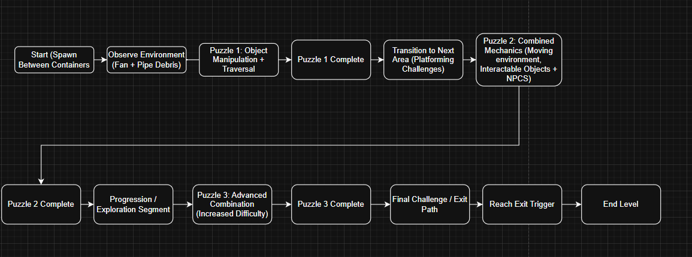
First Puzzle Flow
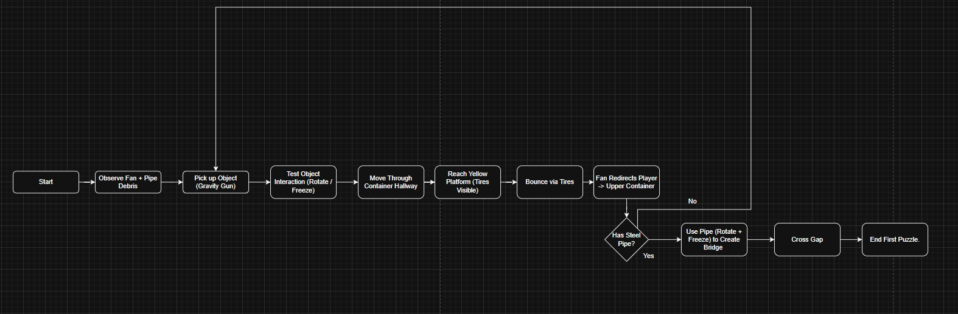
The overall level flow is structured as a series of guided puzzle interactions that gradually introduce and combine the core mechanics of the game.

The player begins in a confined starting area between industrial structures and movement is initially free but visually and guided towards the first key point of interest. The first phase is to observe the interactable objects around them (Spinning Fans, Steel Pipes, Barrels).

Following this, the player then enters an interaction phase where they are encouraged to grab, release, throw and freeze the objects to learn the specific use cases of each action and learn in a low risk environment.

Then they must use what is taught to them in the beginning sequence and first puzzle of the gameplay scene to navigate the level map.

Level Map

Main Level Map
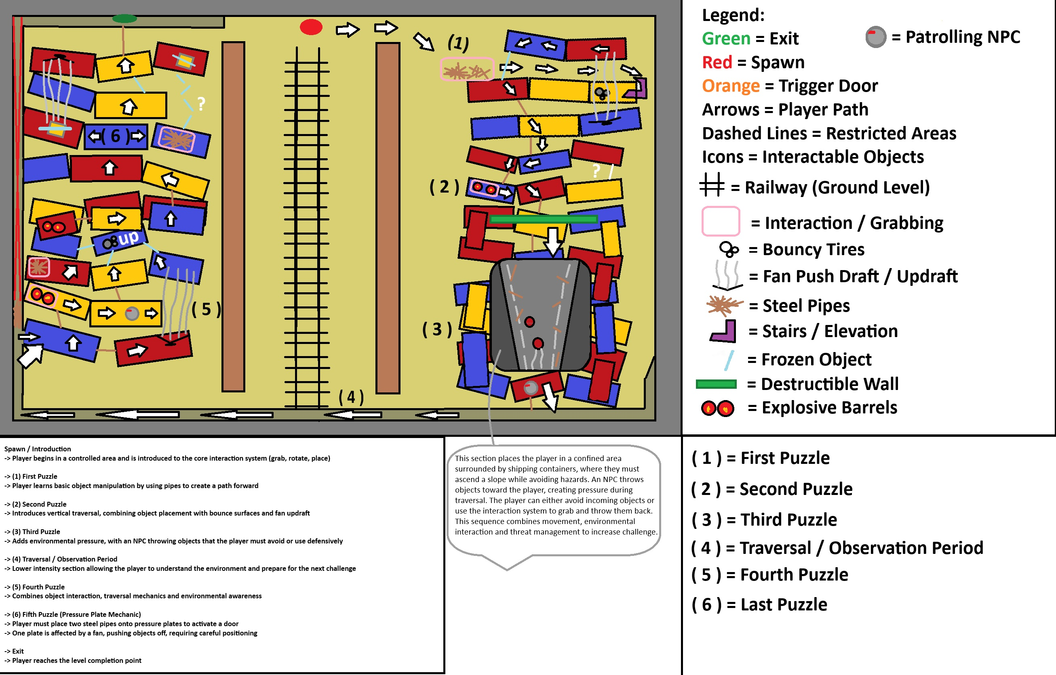
This represents the whole level map and all its puzzles.

The level layout is intentionally designed to guide the player through a structured opening sequence. The first area provides a low risk environment where the player can experiment with the tools provided without any pressure. This allows the player to build confidence with the interaction system before being introduced to more complex challenges.

This demonstrates the use of environmental guidance, where level design subtly directs the player through spatial layout and object placement (Pugh, 2018).

The progression through the level is controlled using spatial design, where pathways, object placement and environmental elements guide the player to the objective. Each puzzle is positioned to increase in difficulty, ensuring the player applies previously learnt mechanics.

Verticality is introduced through the use of stacked containers and elevation changes, encroaching the player to think spatially and use environmental tools such as bounce surfaces or directional forces. This helps to guarantee that the level not only tests mechanical understanding but also reinforces problem solving through the environmental interactions.

Facility
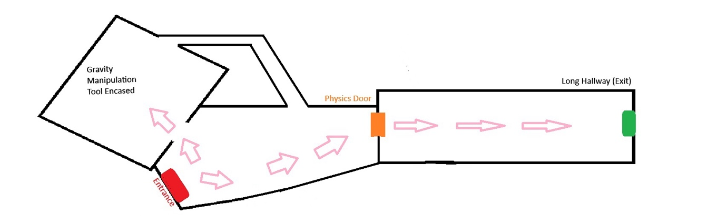This Level map represents the introductory facility space and the first puzzle environment. The map is divided into three primary areas; an initial exploration space, a tool observation area, and lastly the transition corridor to the main game space.
The layout is structured angularly facing toward the exist corridor to subtly guide the player toward that exit and making them aware of the exit condition (Gravity Manipulation), the Gravity Manipulation tool is presented within a visible but contained space which acts like a focal point and a narrative hook.
Lastly, the progression is locked and controlled using a physics door, which acts as a clear transition point between introduction and the main level.
Key Item Locations:
- Gravity Manipulation Tool (encased in observation area)
- Physics Interactable objects (in exploration area)
NPC Locations:
- No NPCs present in the introductory area
Triggers:
- Door interaction trigger
- Area transition trigger (entering hallway)
- Exit trigger at end of corridor
Interactive Environmental Objects:
- Physics based objects (pipes, debris, movable items)
- Environmental props used for interaction testing
Spawn Points:
- Initial Player spawn at entrance of facility

Other Relevant Planning
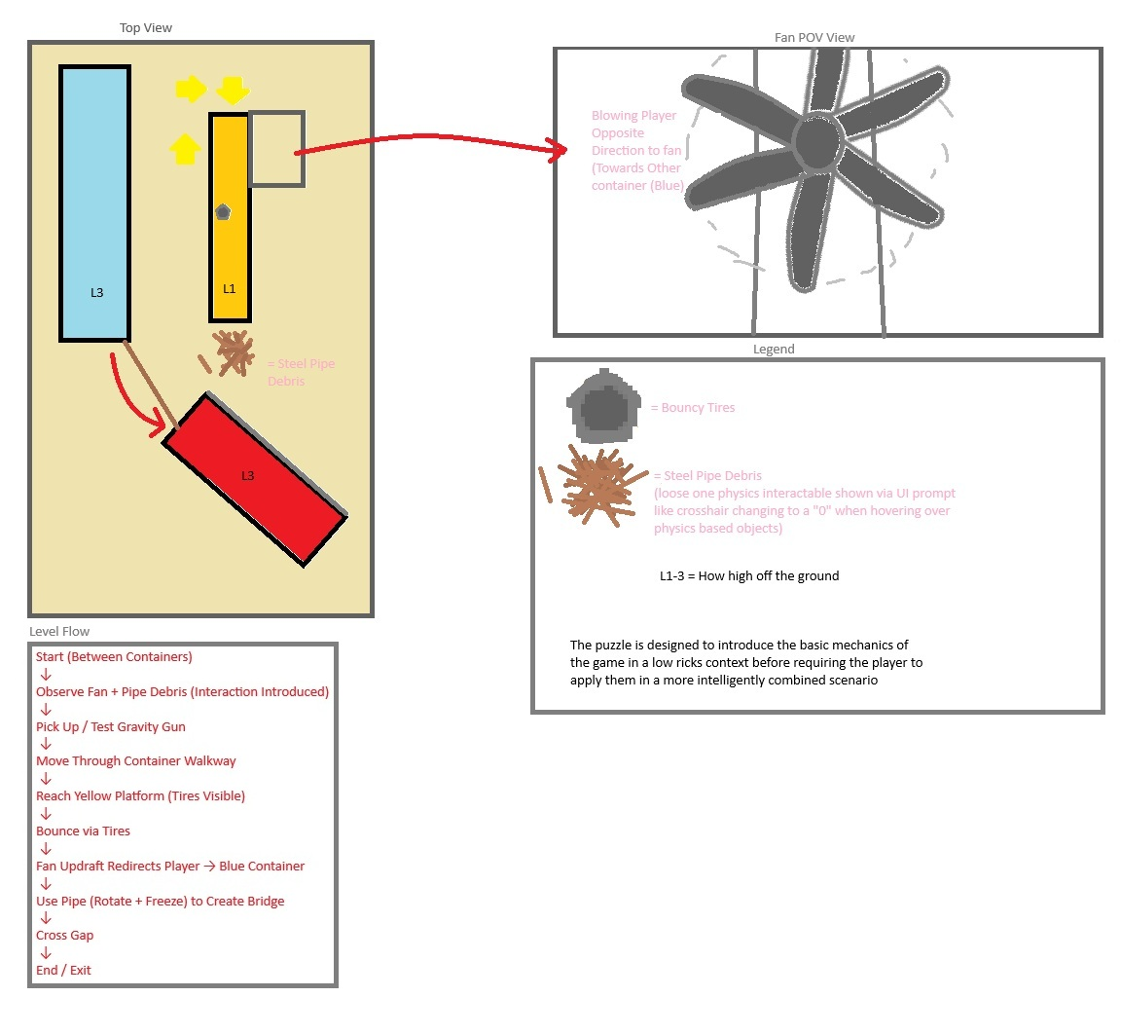

Technical Development Areas
The development of Industrial Ascent followed an iterative design process, beginning with the identification of a core mechanic centred around physics based interaction. Early Prototypes focused on establishing a functional gravity manipulation system that allowed the player to pick up, rotate, freeze and throw objects in the environment.
Once the core interaction was polished enough, the focus shifted towards integrating the system within the level design, Environments were constructed to encourage experimentation, allowing players to interact with objects within a low risk situation before introducing structured puzzles. This ensured the player developed a basic understanding of the mechanics provided rather than just being told.
Further development time was spent refining the player feedback, which includes visual indicators, object behaviour, and environmental cues to help improve the clarity and responsiveness of physics based objects. The level layout was iteratively adjusted to guide the player movement using spatial design, lighting focuses, and environmental composition.
Overall, the process prioritised mechanic first design to land on a solid game mechanic to gameplay loop and established this early to build on it and polish later.

Area 1: Physics Interaction System
The Physics Interaction System is the foundational technical system within Industrial Ascent, enabling the player to manipulate objects within the environment. This system allows objects to respond dynamically to player input through grabbing, releasing and physical interaction using Unreal Engines physics simulation.
The system was designed to prioritise responsiveness and stability, which ensured objects behave predictably. This is essential for maintaining control of the objects and player trust, as the game relies heavily on holding these objects and carefully placing them.
This aligns with Schell (2019), who highlighted that consistent and predictable systems are essential for maintaining player trust and interactive mechanics.
By combining the physics simulation with player controlled input actions, the system allows for engaging and immersive gameplay where the players can experiment with object behaviour and discover multiple solutions to traversal challenges.
Research
Source: Title, Date & Author (chapter / pages) | Unreal Engine Documentation – Physics Components (Epic Games, 2024)
Source’s Concept / Theory & Key Relevant points
The source suggests that physics based systems should balance realism with control. Which helps to create predictable interactions for the player.

Relevant Points:
- The use of Physics Handles to allow controlled object manipulation (currently used)
- Maintaining stable object positioning while being held
- Managing collision to prevent jitter and clipping

Application to your Design
This helped to develop the object interaction system by providing a structured way to grab and move objects using a Physics Handle. It directly influenced how the objects are held in front of the player and how stability issues such as jitter were removed.

Source: Title, Date & Author (chapter / pages) | Half Life 2 Postmortem – Valve (2004)
Source’s Concept / Theory & Key Relevant points
The Half Life 2 postmortem discusses the implementation of the Gravity Gun as a core mechanic, which focused on intuitive interaction and physical believability. It highlights that players should immediately understand how objects behave and feel and be encouraged to experiment.

Relevant Points:
- Immediate visual and physics feedback when interacting with objects
- Consistent object behaviour across different scenarios
- Encouraging experimentation through safe environments

Application to your Design
This influenced the design of the interaction system by reinforcing the importance of clear visual and intuitive control when interacting with a physics based object. It helped shape the decision to allow free experimentation in early areas, ensuring players are familiar with mechanics.

Implementation
The interaction system is driven by a forward sphere trace from the player camera, which checks for physics enabled objects within a certain distance. When the player presses the interaction input, the system calculates the hit result and confirms whether the object contains the required tag for the interaction.
If it is valid, the Physics Handle component is used to attach the object to a controlled position in front of the camera, The object’s transform is continuously updated each frame to maintain a stable hold position.
Additional Logic helps stability of the object by resetting velocity, and rotation values when grabbing, preventing jitter and unwanted motion. While held, the player can rotate the object, freeze its physics simulation, or apply force to throw it.
Key Game Objects
Object: | Image  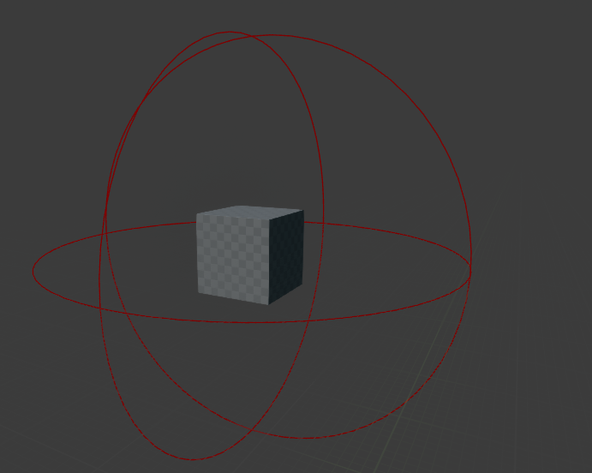
  Name: FN_Physics_Grabbable_Object
  Properties
  - Static Mesh Component
  - Mass and Collision Settings
  - Tag: Physics Object
  Functions
  - Interaction Interface Call
  - Responds to external forces applied by environment or player
  - Can be detected by player line trace
  - Can be manipulated by Physics Handle
Blueprint / Graphs / Processes
- Does not contain active logic or behaviour
Description
Unlike traditional gameplay objects, the Physics objects do not contain their own behaviour logic. Instead, all interaction is controlled by the player character through a centralised system.
This designed helped object management and ensured that consistent behaviour would be displayed across all types of physics behaviour.
Additionally, this Blueprint is a parent class, where all physics objects in the game inherit from this parent class, but the children can inherit their own behaviour as well as the behaviour set on the parent.

Object: | Image  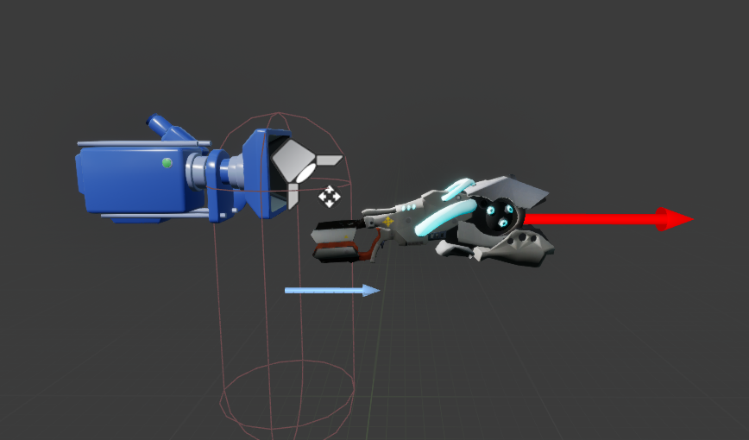
  Name: FN_Player_Character
  Properties
  - Static Mesh Component
  - Character Mesh
  - Spring Arm and Camera
  - Niagra Particle Beam
  - Spotlight (Flashlight)
  Functions
  - Interaction Interface Call
  - Quake Lean
  - Rotate Held Object
  - Freeze Held Object
  - Grab Physics Object
  - Release Physics Object
  - Throw Physics Object
  - Head Bob
  - Sprinting
  - Footstep Trace
Blueprint / Graphs / Processes
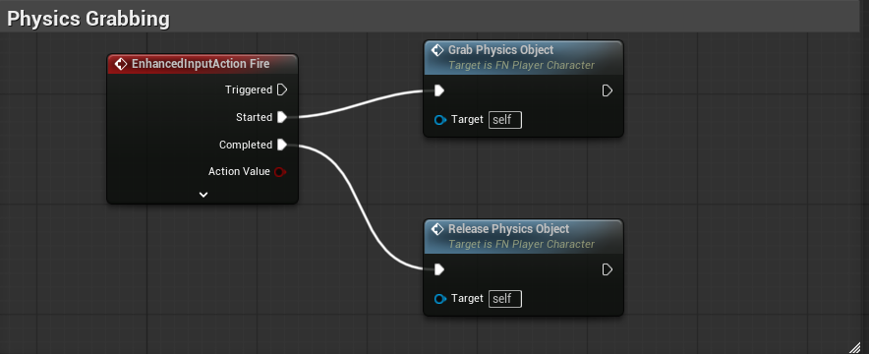
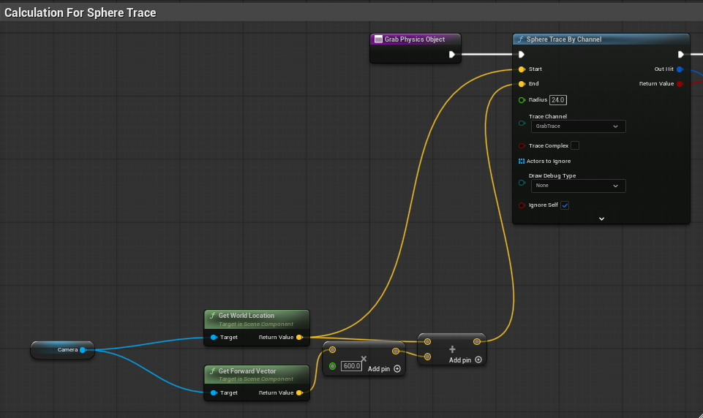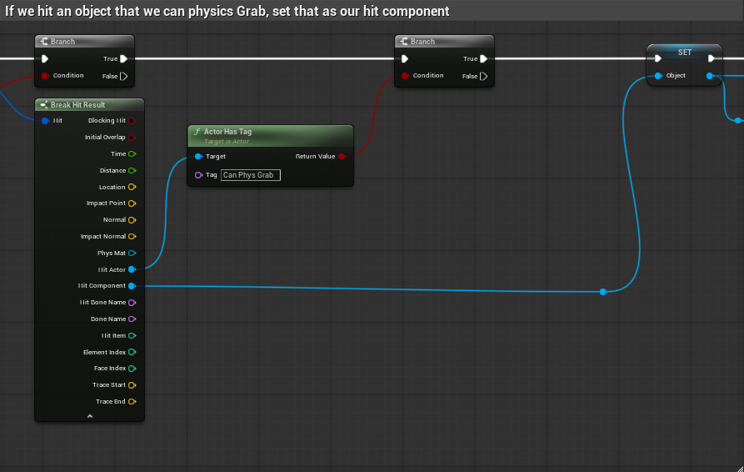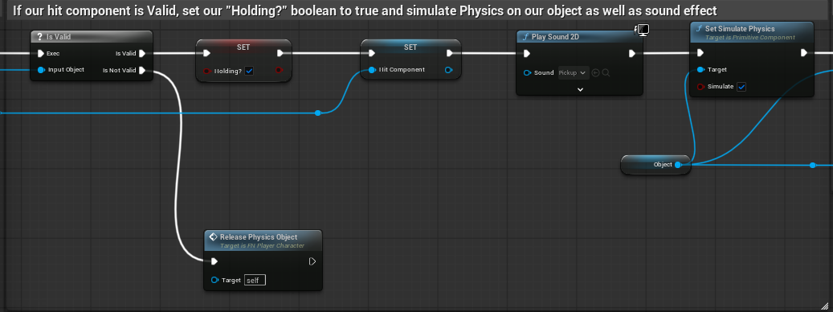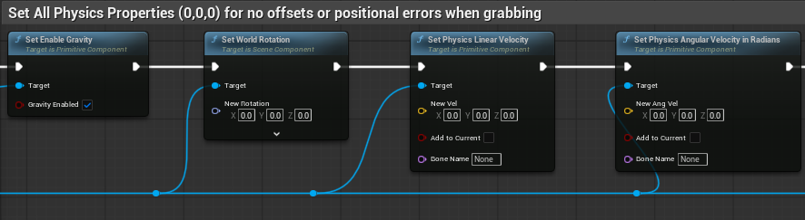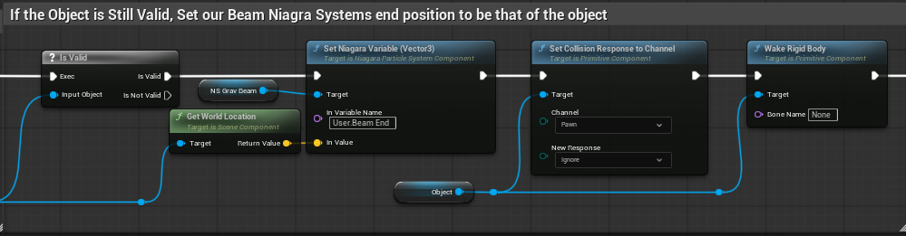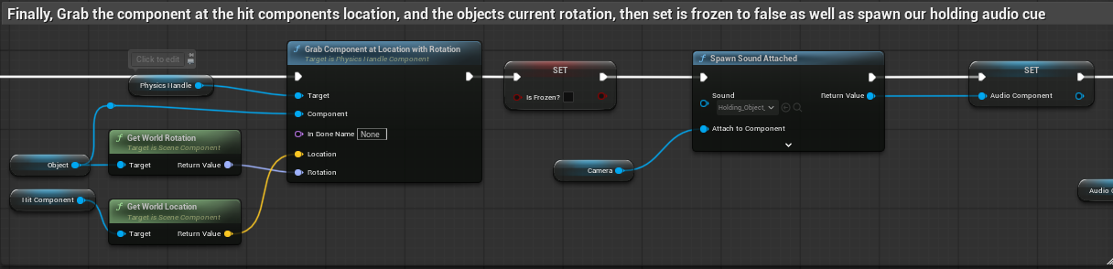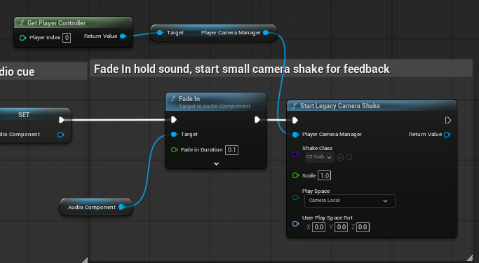
Description
The player character blueprint acts as the central controller for all physics based interactions within the game. Rather than distributing behaviour across multiple objects. All interaction logic is handled by the player, allowing for consistent and predictable behaviour within objects that are physics based.
The system uses a forward trace from the camera to detect physics enabled objects within range. When a valid object is detected, the player can start their interaction through input, which triggers the physics handle system to attach the object to a controlled position in front of the camera.
While an object is held, the player can rotate it using input controls, freeze its position to disable physics simulation, or apply force to it to throw it. Additional system such as camera shake, audio feedback and a Niagara beam effect are used to reinforce the player action and improve interaction clarity.
This centralised approach helped all physics object behave in a consistent way and simplified debugging and allowed new interactable objects to be added without additional logic, as they inherit behaviour from the player driven system.
The grabbing method described above forms part of a wider interaction system, where the player blueprint acts as the central point of control. By handling all interaction logic within the player rather than within individual objects, the method reduced redundancy within logic and allowed new interactable objects to be added without additional scripting, as they conform to the existing interaction system.

Area 2: Player Feedback and Interaction Feedback System
The Player Feedback system is designed to reinforce the players interaction with physics based objects by providing a clear visual, audio and physics response to grabbing, throwing, releasing and freezing objects. It is essential that each interaction feels responsive and understandable. The system combines Niagara visual effects, an object highlight, camera shakes, and audio cues to communicate when an object is being held, grabbed, or released. This improves the clarity, reduces the confusion and strengthens the players sense of control within the game environment.
Research
Source: Title, Date & Author (chapter / pages) | Valve (2004) - Half Life 2 Postmortem (Gravity Gun Design)
Source’s Concept / Theory & Key Relevant points
- Feedback is critical for physics based interaction
- Players must:
  - Feel the connection between them and the object they’re holding.
  - Understand interaction states instantly

- Use:
  - Visual Effects
  - Sound
  - Motion Feedback

Key points:
- Immediate Feedback reinforces interaction
- Physics systems must feel responsive and readable
- Feedback encourages experimentation

Application to your Design
This source reinforced the importance of a strong visual and physical connection between the objects and the player. It influenced the use of a Niagara Beam to visually connect the player and object, alongside a small camera shake and audio cues to help sell the interaction states. This ensured that the player receives continuous feedback during object manipulation which made the system instantly feed more responsive and intuitive.

Source: Title, Date & Author (chapter / pages) | Norman, D. (2013) - The Design of Everyday Things
Source’s Concept / Theory & Key Relevant points

This source although not game specific, provides fundamental design principles. It explains that feedback is a fundamental principle of good design, as it communicates the result of an action back to its user. Systems should provide immediate and clear feedback so that users can understand what has happened after they perform the action.

Norman highlights that without feedback, users may become confused or unsure whether their action was successful. Effective feedback can be delivered through multiple forms, including visual, audio and physical responses.

Key Relevant Points:
- Feedback communicates the RESULT of an action
- Feedback should be IMMEDIATE and noticeable
- Multiple feedback types to improve clarity
- Lack of feedback reduces the usability and user confidence

Application to your Design

This source directly influenced the importance of player feedback and the immediate response to actions with feedback. In Industrial Ascent, visual feedback such as the Niagara Beam, combined with the camera shake, object highlight and audio cues, help to create clean and readable feedback for the player so they can understand when an object has been grabbed, released, thrown or frozen.

By applying the principles, the system reduces confusion and improves the player clarity, making the physics interactions feel more responsive.

Implementation
The feedback system is triggered alongside the interaction system and is event driven based on the player actions. When an object is successfully grabbed, the Niagara beam is activated and its start and end positions are updated each frame to visually connect the player to the object.
Camera shake is triggered using the player camera manager to simulate physics interaction and reinforce the impact when grabbing, throwing or releasing objects. Audio cues are played at key interaction points to confirm the actions such as picking up or releasing.
A separate trace system is used to detect interactable objects before interaction, applying a highlight effect to indicate that the object can be used. This ensures that feedback is both reactive and that you can know what to expect before and after interaction.
Objects
Object: | Image  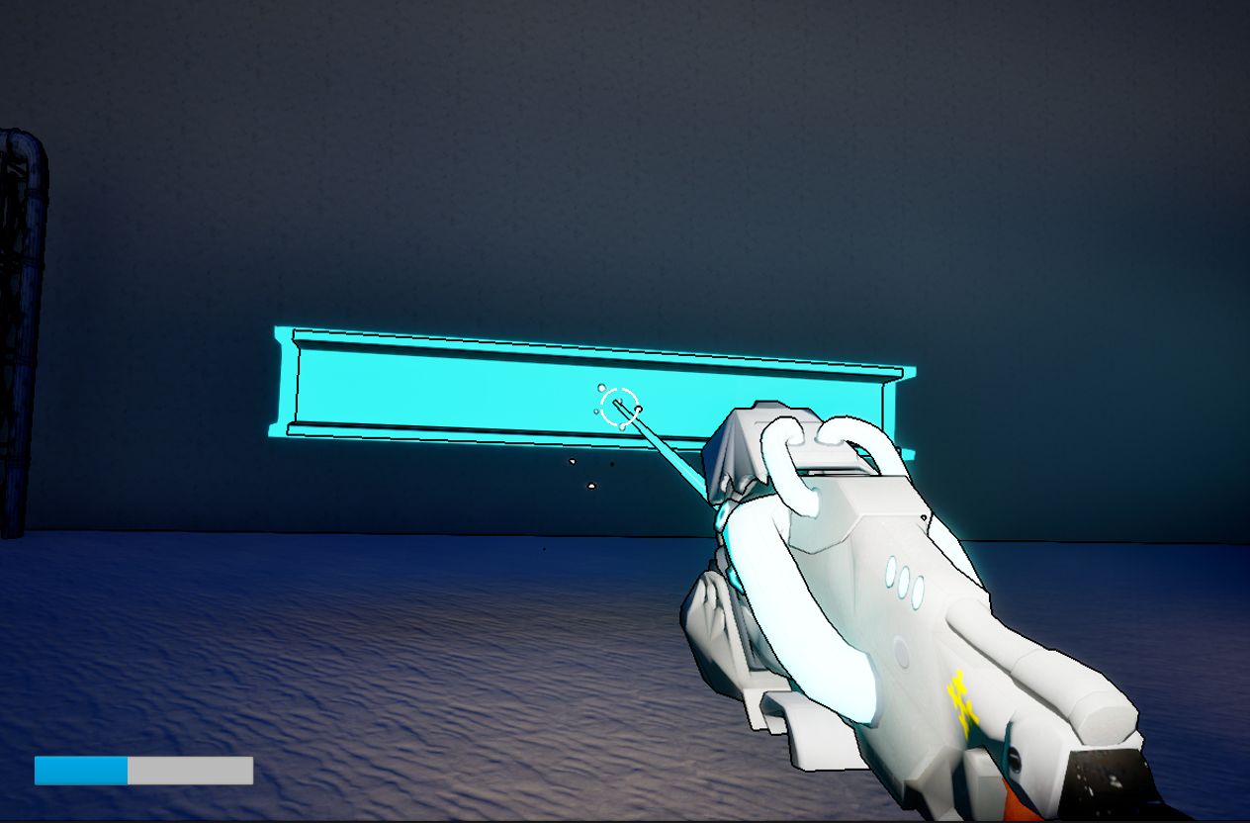
  Name: FN_Player_Character
  Properties
  - Niagara System (Beam Effect)
  - Camera Manager Reference
  - Audio Component
  - Highlight Material
  Functions
  - Trigger Legacy Camera Shake (Grab / Throw / Impact)
  - Play Sounds (Pick up, Release, Rotate, Impact)
  - Update Niagara Beam Position (line trace)
  - Apply Highlight to Interactable Objects
Blueprint / Graphs / Processes
Beam / Object Position Graph:
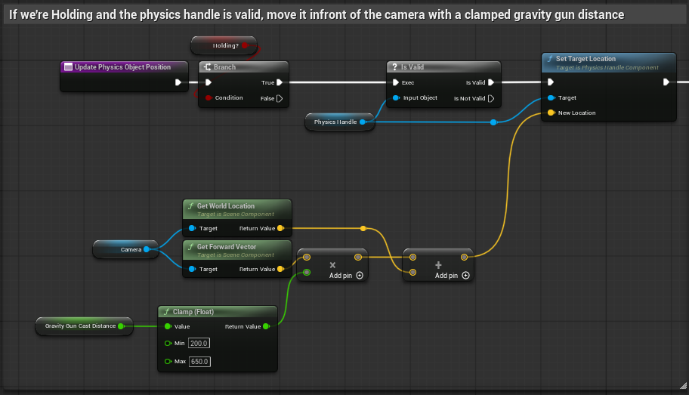
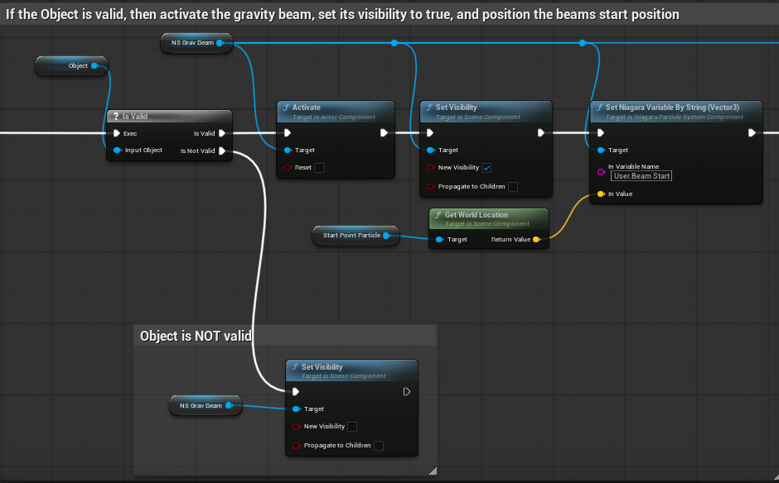
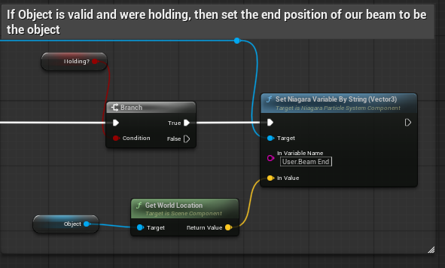
Crosshair / Outline Update:
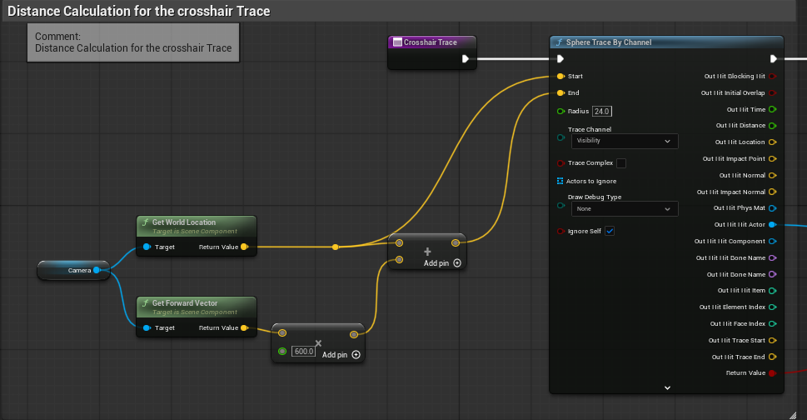
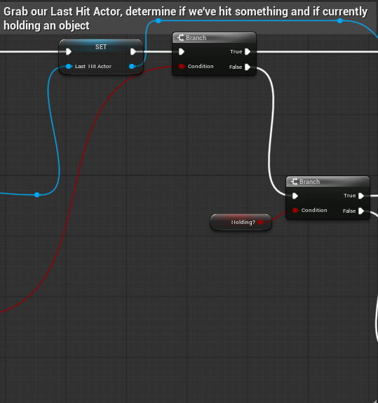
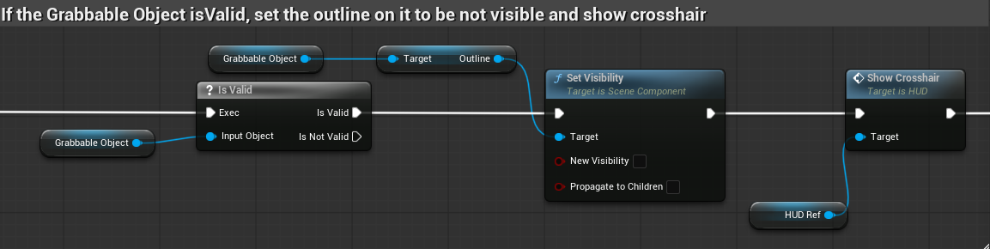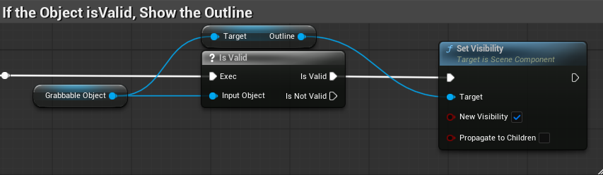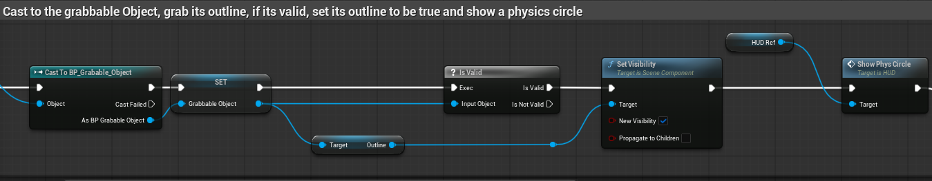
Description
The feedback system is implemented within the player character blueprint to ensure all interactions are consistently reinforced through visual, audio and physical response. When the player interacts with an object, multiple feedback layers are triggered simultaneously, including a Niagara Beam to visually connect the player to the object, a camera shale to simulate physical impact and audio cues to confirm the action.
The system uses the same forward trace as the interaction system to detect valid objects and applies a highlight effect to indicate interactivity. This ensures that feedback is not only reactive but also anticipatory, which helps the player understand what can be interacted with even before performing an action.
By combining multiple feedback types, the system improves clarity, responsiveness and player confidence ensuring that all interactions feel immediate and understandable.

Area 3: Environmental Puzzle Design
The environmental puzzle design system focuses on how physics based objects and environmental mechanics are combined to create gameplay challenges within the level. The system is built around the core interaction loop of (Grab -> Rotate -> Place -> Traverse), which requires the player to apply previously learnt mechanics to progress.
Rather than presenting single use mechanics, the system integrates multiple object types such as pipes, tires and fan driven updrafts into structured puzzle scenarios. These objects act as tools that the player must use to construct paths, reach new areas and overcome traversal challenges.
The system is design to encourage experimentation and problem solving by allowing multiple possible solutions while still guiding the player through level layout, object placement and environmental cues.
Research
Source: Title, Date & Author (chapter / pages) | Valve (2004) - Half Life 2 Postmortem (Level Design & Gravity Gun)
Source’s Concept / Theory & Key Relevant points

The source suggest that gameplay mechanics should be introduced gradually through level design, allowing players to learn through interaction rather than instruction. It highlights the importance of combining mechanics in later stages to increase complexity while maintaining player understanding.

Key Relevant Points:
- Mechanics should be introduced gradually in low risk environments
- Puzzles should combine previously learned mechanics.
- Level design should guide the player naturally
- Players should learn through experimentation

Application to your Design
This directly influenced the structure of the level, where the player is first introduced to basic interaction in a safe space before being required to apply those mechanics in a more complex puzzle. The use of pipes, tired and fans in combination reflects this approach, gradually increasing the difficulty while maintaining clarity.

Source: Title, Date & Author (chapter / pages) | Valve (2004) - Half Life 2 Developer Commentary
Source’s Concept / Theory & Key Relevant points
The developer commentary for Half Life 2 explains how physics based gameplay and environmental puzzles were designed around the gravity gun mechanic. Valve describes how the game was built so that physics interactions became the core of gameplay, with the levels specifically structured to encourage players to experiment with objects and discover solutions naturally.

The commentary highlights that:
- Gameplay systems are introduced first, then expanded through level design
- Objects are selected and refined based on how well they work with the core mechanic
- Puzzles are built by combining the mechanics rather than explaining them directly
- The game responds to player actions to reinforce learning and understanding

Also, the gravity gun allows players to use everyday objects as tools for traversal and problem solving, such as forming bridges or reaching new areas.

Application to your Design

This directly influenced the environmental puzzle design system in Industrial Ascent, where physics objects such as pipes, jump pads and fans are used as tools to create traversal challenges. Like Half Life 2, the player is first introduced to interaction mechanics before being required to combine them in more complex scenarios.

The design follows the same principle of allowing players to experiment with objects to discover solutions, rather than relying on told instructions. This ensures that puzzles remain intuitive whilst still providing the challenge, this reinforces the use of the core interaction system as the primary method of progression.

Implementation
Objects
Object: | Image  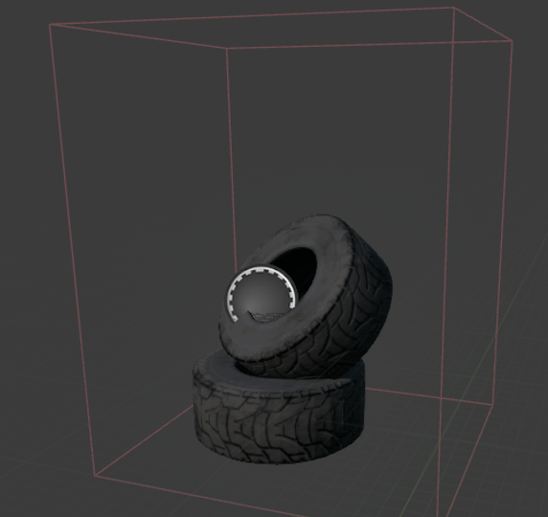
  Name: FN_JumpPad
  Properties
  - Static Mesh Component
  - Box Collision (Trigger)
  - Launch Strength (Float)
  - Launch Direction (Vector – Up)
  - Overlap Events Enabled
  Functions
  - OnComponentBeginOverlap
  - LaunchCharacter
  - Play Sound
Blueprint / Graphs / Processes
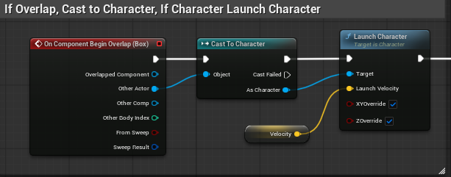
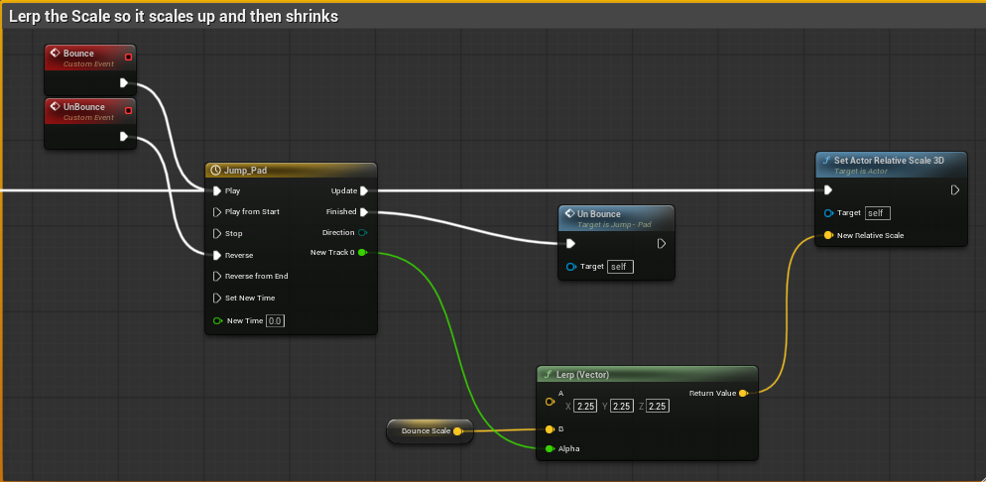
The JumpPad uses a Box Collision component to detect when the player enters its trigger area. When an overlap occurs, the system checks if the overlapping actor is the player character. If its valid, then the LaunchCharacter function is called, applying an upward force based on the launch strength. This then launches the player vertically upward.
Description
The JumpPad functions as a vertical traversal mechanic within the environmental puzzle system. It allows the player to reach elevated areas that cannot be accessed through standard movement. The object is often used in combination with other mechanics, such as fan updrafts, to create multi stage traversal challenges.
By integrating the JumpPad into level sequences, it expands the players movement capabilities and reinforces the use of environmental objects as tools for progression.

Object: | Image  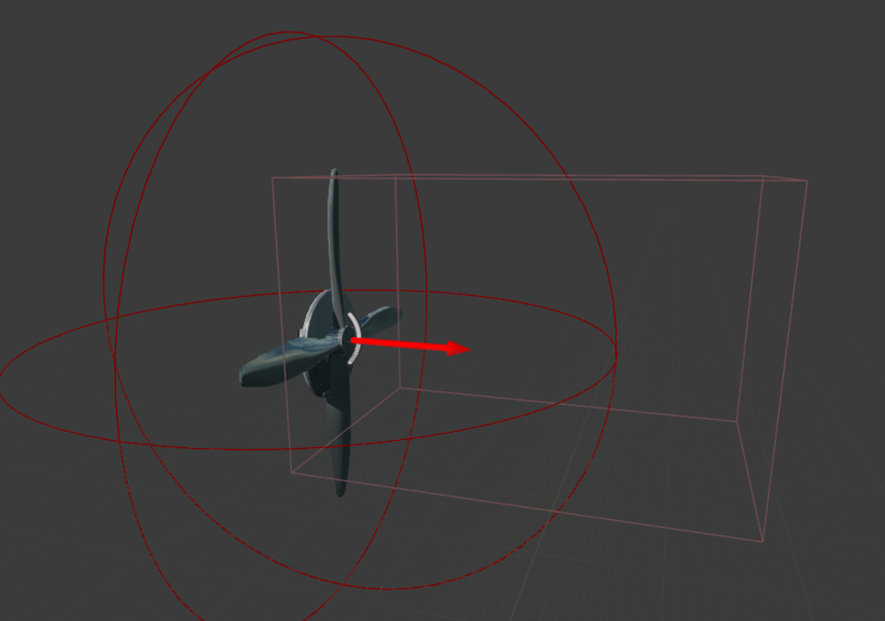
  Name: FN_Fan
  Properties
  - Static Mesh Component
  - Box Collision (Up-Draft Area)
  - Force Strength (Float)
  - Force Direction (Vector Up / Forward)
  - Rotation Movement Component (Fan Model & Visual Feedback)
  Functions
  - OnComponentOverlap (Detect Player in Air)
  - Apply Continious Force (Add Force / Launch)
  - (Niagara Wind & Sound Effect)
Blueprint / Graphs / Processes
The Fan system uses a box collision volume to define airflow area. When the player enters this area, a directional force is continuously applied to the character. This force is calculated using a predefined direction vector and strength. Simulating an updraft or push effect.
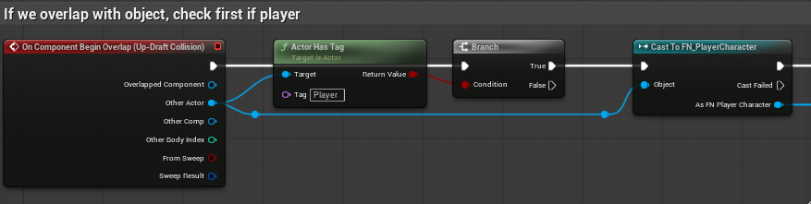
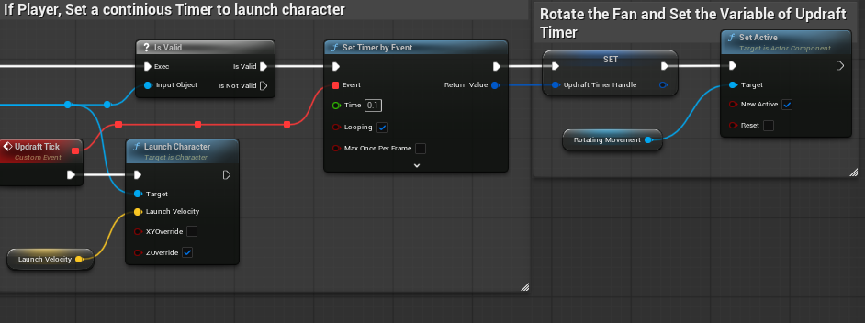
The fan mesh rotates using a rotation component to visually communicate its active state. The force remains active while the player is within the Collison volume, allowing controlled movement across gaps for vertical or horizontal draft
Description
The fan introduces directional movement into the puzzle system, allowing the player to be lifted or pushed across the environment. It is commonly combined with the JumpPad to create layered traversal challenges that require timing and positioning.
This object reinforces the concept of environmental integration by demonstrating how different forces can be combined to achieve progression, encouraging experimentation and spatial awareness.

Testing and Problems
The project was tested through both functional testing and informal playtesting to ensure that all core systems operated as intended and provided a clear user experience. Functional testing focused on verifying that key mechanics such as object interaction, feedback systems and physics behaviour all worked reliably under different conditions. This included testing edge cases such as object collisions, rapid input changes, and interaction at different distances.
In addition, formal playtesting was conducted to evaluate how intuitive the system felt to the player. This helped identify issues such as interactions states and lack of feedback, which were later resolved through the implementation of visual highlights, audio cues and camera shakes. This combined approach ensured that both the technical functionality and the overall player experience were refined.

Problems
Priority | Problem | Solution | Implemented
Low | Camera Jitter when holding objects | Adjusted physics handle dampening | Jitter has lowered, adjust again.
High | Object Clipping into walls | Change the objects trace channel to a custom one | uninterrupted grabbing now.
Med | Beam position not updating | Validity Checks at each step | Beam now updates its position correctly, following the object and its origin no problem
Med | Feedback Too Weak | Increase Shake + add Sound | Feedback now feels responsive and objects feel more alive
High | Player Confusion Early | Add object highlight system | Adds more visual clarity to which objects you can pick up.

Critical Review

Strengths of the Project:
One of the main strengths of the project is the implementation of the physics interaction system. The system allows for the player to directly manipulate objects in a responsive and controlled way, creating a strong sense of player control. By centralising all logic within the player blueprint, the system remains consistent and scalable, allowing new objects to be made without any further scripting.
Another key strength is the clarity of player feedback. The combination of visual, audio and physical feedback helped to communicate all interactions well. This approach aligns with what of Don Norman and their design principles, immediate feedback improves usability and understanding. As a result, interactions feel responsive and intuitive improving clarity and reducing confusion.
The environmental puzzle design is also a strong aspect of the implementation, the level introduces mechanics gradually and then combines them in later puzzles, encouraging experimentation and problem solving. This reflects an industry approach used in Half Life 2, where players learn through challenges rather than direct instructions. This structured style of progression helps maintain player engagement and supports the development of skills with the provided tools.
Areas for Improvement:
One area that could be improved is the variation of the level. Overall, the current puzzles effectively use physics interaction, the type of interactions that are present are few and could have benefitted from being expanded further or introducing slight variations like timed elements or alternative puzzle solutions. These changes could have brought longer play time and help to maintain the replay ability of the game.
Another limitation is the implementation of NPC Interaction. Although NPCs are present and introduce environmental pressure, their behaviour is relatively simple. Expanding this system to include more complex AI behaviour like, varied attack patterns or reactive movement would most definitely enhance the gameplay depth and align more closely with the brief requirements.
Additionally, some aspects of the level layout could have been refined to improve clarity. While the level generally guides the player effectively, certain areas may benefit from stronger visual cues or environmental signposting, this would help to guarantee the players can more easily identify the objectives within the level and reduce potential frustration.
What did not go well:
During development maintaining stable physics behaviour presented challenges, specifically when objects were interacting with the environment when being held, they would clip into other objects or jitter nonstop. Additional refinement into the real time physics system in Unreal Engine, and how the Physics Handle controls objects to resolve the issues. The problems that were encountered highlighted how frustrating working with real time physics can be due to the iterative testing approach that has to be undergone to achieve consistent results.
What could have been done better:
More time could have been allocated for expanding NPC behaviour, or puzzle variation. While the core systems of the game were prioritised to implement a more polished gameplay loop, additional time should have been spent developing more diverse gameplay scenarios and a higher level of polish. Earlier testing for expanded ideas could have been tested earlier and had areas for improvement that would be rectified if they were developed earlier on.
What has been learnt:
This project has highlighted the importance of creating a strong core mechanic. By focusing on physics interaction early, it allowed for a consistent and scalable system to be implemented that supported both the level design and user experience.
It also demonstrates the importance of iterative testing, as many issues such as physics instability, and unclear feedback were only identified due to repetitive playtesting. Additionally, the project also demonstrates how combining simple mechanics can create complex and engaging gameplay when supported by clear feedback and structured progression.

Conclusion

The development of Industrial Ascent demonstrated how a strong core mechanic can be used to support both gameplay and level design. By focusing on physics interactions, the project was able to create a consistent gameplay loop centred around object manipulation and environmental problem solving.

Key concepts such as player feedback, structured progression and environmental design were essential for ensuring that user experience remained clear and engaging. The combination of visual, audio and physical feedback improved interaction clarity, while the level design allowed mechanics to be introduced gradually and combined in meaningful ways.

These concepts are widely supported in design theory, where clear feedback, structured progression, and environmental interaction are fundamental to effective player experiences (Norman, 2013, Fullerton, 2018).

Overall, the project reinforces the importance of iterative development, where testing and refinement play a key role in improving system functionality and player experience. The final result is a cohesive prototype that demonstrates the potential of physics based gameplay within a structured level design.

References
Norman, D. (2013). THE DESIGN OF EVERYDAY THINGS. [online] Available at: https://media.aanda.psu.edu/sites/media/aa/files/documents/norman_design-of-everyday-things.pdf.
2kliksphilip (2024). HL2 Dev Commentary Part 4 - Water Hazard. [online] YouTube. Available at: https://www.youtube.com/watch?v=JZ6-TssJV2g [Accessed 3 Apr. 2026].
Physics Components in Unreal Engine | Unreal Engine 5.7 Documentation | Epic Developer Community (2026) Epic Games Developer. Available at: https://dev.epicgames.com/documentation/unreal-engine/physics-components-in-unreal-engine (Accessed: 3 April 2026).

Classic Postmortem: The making of Half-Life 2 (2015) Gamedeveloper.com. Available at: https://www.gamedeveloper.com/design/classic-postmortem-the-making-of-i-half-life-2-i-.

Schell, J. (2008) The Art of Game Design. Available at: https://www.inventoridigiochi.it/wp-content/uploads/2020/07/art-of-game-design.pdf.

‌ Allan, D. (2017) Designing Video Game Puzzles, Game Developer. Available at: https://www.gamedeveloper.com/design/designing-video-game-puzzles.

Cyberly (2025) What Are Environmental Puzzles In Video Games?, Cyberly.org. Available at: https://www.cyberly.org/en/what-are-environmental-puzzles-in-video-games/index.html (Accessed: 8 April 2026).

Pugh, T. (2018) Level Design Tips and Tricks, Game Developer. Available at: https://www.gamedeveloper.com/design/level-design-tips-and-tricks.

Bibliography

https://www.youtube.com/watch?v=JZ6-TssJV2g
https://media.aanda.psu.edu/sites/media/aa/files/documents/norman_design-of-everyday-things.pdf.
https://liminal-space-dev.itch.io/free-horror-sfx-sounds
https://sketchfab.com/3d-models/industrial-asset-pack-free-94c5011772a84e8791779b342467f245

https://sketchfab.com/3d-models/gravity-gun-67e21e0c431c427bbcdac5c3149fbb35

https://dev.epicgames.com/documentation/unreal-engine/physics-components-in-unreal-engine

https://www.gamedeveloper.com/design/classic-postmortem-the-making-of-i-half-life-2-i-

https://www.inventoridigiochi.it/wp-content/uploads/2020/07/art-of-game-design.pdf.

https://www.gamedeveloper.com/design/designing-video-game-puzzles.

https://www.cyberly.org/en/what-are-environmental-puzzles-in-video-games/index.html

https://www.gamedeveloper.com/design/level-design-tips-and-tricks

Appendices
https://www.youtube.com/watch?v=yZkUZg_wono&t=2s
Screenshot 1 (Niagara Beam Feedback)
This screenshot demonstrates an early implementation of player feedback using a visual beam (Niagara System) to indicate which object is currently being held. The system is controlled via an exposed Vector3 variable within the blueprint.
An initial issue was identified where the beams position was not updating correctly when driven by Tick or a Timer. The issue was traced to a confliction between the grabbing logic and the beam itself, as both system attempted to update the beam at the same time. The issue was resolved by moving the update logic through a Timer, resulting in consistent and accurate position updates.
Screenshot 2 (Beam Collision & Trace Logic)
This screenshot shows further testing of the player feedback system alongside the gravity gun interaction. During testing, it was seen that the beam could be obstructed when the player moved around held objects, causing them to visually stick to nearby objects.
This behaviour was caused using a standard trace channel, which allowed the beam to collide with all objects in the scene, to resolve this a custom trace channel was made which ensured that only the relevant objects were detected.
As a result, when the beam is obstructed, the held object now smoothly interpolates back toward its intended holding position. This behaviour is enabled by the held object maintaining collision, allowing for more stable and predictable interaction.
Screenshot 3 (Trace Input Issue)
This screenshot highlights an early issue encountered during the implementation of the gravity guns trace system. The trace logic was initially bound to a Triggered input event, causing it to fire continuously rather than at controlled intervals.
This resulted in inconsistent behaviour, where objects could not be rotated or manipulated correctly while the trace was active. The constant firing of the trace interfered with the object interaction logic, which would just override its rotation updates.
The issue was resolved by restructuring the input handling, making sure the trace was executed in a more controlled manner. This allowed the object manipulation to function reliably.
Screenshot 4 (Final Gravity Gun Implementation)
This screenshot shows the final implementation of the gravity gun system. The interaction logic has been stabilised, allowing objects to be continuously grabbed held and rotated.
Visual feedback has been improved using emissive highlighting and a refined beam system. Clearly indicating the currently selected object. The system now supports smooth object movement and rotation without interference from the tracing logic, which results in a more responsive and intuitive experience.
Appendix A (Controls)
- Movement:
  - W / A / S / D – Move Player
  - Mouse – Look Around
- Interaction:
  - E – Interact
  - Left Mouse Button (Hold) - Grab Object
  - Right Mouse Button – Throw Object
  - Mouse Scroll Up / Down – Rotate (Left / Right)
  - F – Freeze Object
  - R – Rotate (Bigger Increments)
- Traversal:
  - Space – Jump
  - Shift (hold) - Sprint
- System Behaviour:
  - Objects can only be interacted with when within range of the players trace
  - Held objects follow the player camera position
  - Frozen objects disable physics simulation and remain fixed in place.

Walkthrough and Cheats
Appendix B (Walkthrough)
First Puzzle & Introduction Walkthrough
- Player Spawns in the facility introduction area.
- Player explores the environment and observes interactable objects (highlighted blue)
- Player approaches gravity manipulation tool in the observation area.
- Player interacts with the tool to unlock core mechanics (grab, rotate, freeze, throw).
- Player experiments with objects in a low risk environment.
- Player progresses through corridor by pulling the physics door off and walking down hallway.
- Player enters main puzzle area.
- Player walks through container walkway with grab able steel pipe.
- Player walks into Tire bounce and fan updraft whilst holding pipe.
- Player uses a steel pipe to bridge the gap between the two containers.

Game Assets
Graphical Assets
Image | name | Used for | Sourced from
 | Gravity Gun | PC Gravitational Manipulation Tool | https://sketchfab.com/3d-models/gravity-gun-67e21e0c431c427bbcdac5c3149fbb35
 | Industrial Asset Pack (Free) | Industrial Environment Assets | https://sketchfab.com/3d-models/industrial-asset-pack-free-94c5011772a84e8791779b342467f245
 | Free Horror SFX | Ambient Wind | https://liminal-space-dev.itch.io/free-horror-sfx-sounds
 | Industrial Revolution | Game Font | https://www.dafont.com/industrial-revolution-2.font
 | Free Input Prompts Pack | UI Input Pack | https://juliocacko.itch.io/free-input-prompts

Audio Assets
Most audio assets were edited and refined in Audacity to adjust volume level and apply some variety in the types of sounds that are played.
Sound | Used for | File & Source
Audio Feedback (Player Interaction) | - Grab Sound  - Release Sound  - Throw / Freeze Sound | Drop_Physics_Object.mp3  Place_Object.mp3  Throw.mp3  Pickup_Physics_Object.mp3
Environmental Audio | - Ambient Wind (externally sourced)  - Fan Loop (looped + attenuated) | https://liminal-space-dev.itch.io/free-horror-sfx-sounds  Ambient_Wind(1-8).wav
Movement Audio | - Footsteps (Metal + Concrete) | Metal_Footstep.mp3 (1-4)  Concrete Footstep.mp3 (1-4)
Gameplay Objects | - Button Press  - Jump Pad trigger | Bounce.mp3  Button_Press.mp3

