University of Brighton
Computer Games



CI414 - Game Design & Development 2024 -5
Coursework: Unreal Game

Module Leader: David Dorrington

Student: Finley Nye FN170
Date: 10/03/2025

Contents

Contents 1
Introduction 2
Game Idea 3
Game Design Decisions 4
GUI / HUD Design 6
NPC Interaction 7
Theoretical Research 7
Layout & Combat Design 8
Game Design & Flow 9
Game Flow with Events 9
Planned Level Events 10
Level Gameplay Events Details 10
Level Map 10
Puzzle Designs 10
Implementation, Testing & Problems 10
Key Game Objects Developed 10
Testing and Problems 10
Playtesting feedback 10
Problems 10
Critical Review 10
Conclusion 10
References 10
Bibliography 10
Appendices 10
UML Diagrams for Game Objects: 10
Walkthrough and Cheats 10
Level 1 Walkthrough 10
Game Assets 10

Introduction
This document covers the concept and development of BOOM GUY, It covers topics from visual style, player experience to gameplay mechanics and Design Pillars.

Game Idea
The game is a DOOM inspired survival horror FPS set in an intergalactic space prison. The player takes on the role of Boom Guy, a prisoner who needs to escape the prison by ascending from the lowest level to the top. The game retains the retro Low Poly aesthetic with a VHS style visual filter, enhancing the gritty, sci-fi horror atmosphere.
The primary objective is to escape the prison by navigating through multiple levels, each filled with hostile guards, environmental hazards, and locked sections. The player must manage limited resources, solve puzzles, and uncover the dark secrets of the prison through environmental storytelling and hidden lore.

Game Design Decisions
Element | Details
Working title | BOOM GUY.
Concept | A retro stylistic fps set aboard a space prison where the primary objective is to ascend whilst battling enemies and challenges.
Genre | Survival, Horror, FPS
Theme | Sci-Fi, Horror, Survival, Retro 90’s Vibe
Design Pillars | - Relentless Combat: Fast paced, violent gunplay that keeps the player on edge.  - Resource Management: Limited ammo, health, and key items increase tension and survival pressure.  - Tense Exploration: Designed to make the player feel vulnerable in unfamiliar environments while encouraging exploration.  - Progressive Challenge: Increasing difficulty as the player ascends through the prison, adding new challenges and enemies
Player Experiences | - Desperation: Struggling to survive with limited resources.  - Triumph: Overcoming tough enemies or deadly situations.  - Isolation: Feeling alone and trapped in the space prison.  - Adrenaline: Fast, intense combat that gets your heart racing.
Overall Goal of Game | The player must escape the intergalactic space prison by ascending through multiple levels, overcoming enemies, environmental hazards, and puzzles while uncovering the dark secrets of the facility.
Core Gameplay | - Fast-paced, DOOM-inspired shooting.  - Resource management (ammo, health, keycards).  - Environmental exploration and puzzle-solving.  - Diegetic guidance through level design, lighting, and sound.  - Tension-building through low resources and high-risk encounters.
Main Gameplay Challenges | - Surviving enemy encounters with limited resources.  - Solving environmental puzzles (power overrides, terminal overrides).  - Navigating hazardous areas like zero-gravity zones, malfunctioning traps, and locked doors.  - Managing health, ammo, and items under constant pressure.
World Information | The game is set in Echelon 9, a massive intergalactic prison adrift in deep space. Once a high security fortress, it’s now a death trap overrun by malfunctioning security bots and hostile alien experiments, all sent by the King of Neptune in retaliation for Boom Guy assassinating the Grandmaster of Pluto, stripping the planet of its status. Dark secrets linger in the prison’s depths and escaping means fighting through waves of chaos to uncover the truth.
Environment Style | - Industrial Brutalism: Heavy use of cold, metallic architecture mixed with decayed interiors.  - Retro VHS Horror: Grainy, analogue style visuals with heavy post-processing effects to simulate old VHS tapes.  - Claustrophobic Corridors: Narrow, dimly lit hallways with flickering lights to amplify dread.
Key Locations | - Cell Blocks: Where prisoners were held. Dark, crowded spaces filled with malfunctioning security bots.  - Maintenance Deck: Packed with industrial machinery, exposed wires, and deadly traps.  - Nuclear Reactor Plant: The final level where the player must escape from the prison's imploding nuclear plant to escape
Settlements | None, the prison is abandoned and overrun. Any remnants of human life are only found through logs or environmental storytelling.
Art Style | - Low Poly Retro 3D: Inspired by PS1/N64 graphics, with sharp edges and minimal textures.  - VHS Visual Filter: Heavy grain, chromatic aberration, and subtle distortion to resemble old horror movie tapes.  - Dark, Muted Colour Palette: Heavy use of greys, greens, and metallic tones to capture the industrial prison vibe.
Audio Style | - Heavy Industrial Ambiance: Mechanical hums, distant robotic growls, and subtle alien noises.  - Gritty Soundtrack: horror music, similar to old-school DOOM/Quake with oppressive, dark undertones.  - Diegetic Audio Cues: The environment provides audible feedback, such as flickering lights, malfunctioning machinery, and distant screams.  - Minimal Dialogue: All story elements are delivered through environmental storytelling or audio logs.

GUI / HUD Design

Health will be displayed with a Blueprint Widget and will be a slider of some sort in a red colour to try match the grungy theme and will be placed according to theoretical research about gameplay and UI/UX Design.

NPC Interaction

The NPC Interaction the game will include a series of audio logs that can be found at the corpses of the dead guards, this can include lore or diegetic clues or just the final moments before they perished.

Theoretical Research
Source: Title, Date & Author (chapter / pages) | Combat – The Level Design Book (2016), leveldesignbook.com
Source’s Concept / Theory & Key Relevant points
The source emphasises the importance of combat zones within combat design. (places where enemies and players meet one another). The ideas that were discussed within the source are;
Player, AI Dynamics
Space & Flow
Pacing

Application to your Design
This directly influenced the opening sequence of the first level. Debris was strategically placed around the opening area to influence the player to take a more linear path helping them to success

Source: Title, Date & Author (chapter / pages) | DOOM Franchise (1993-Present), id Software / Bethesda
Source’s Concept / Theory & Key Relevant points

- Speed & Simplicity: From the original Doom to the latest in the franchise. It strips away any unnecessary complexity (reloading, cover systems) for frictionless movement and shooting.

- UI Parallel: Early Doom used a minimal HUD, while modern titles layer meta UI (flame animations on low health). Both prioritise being able to read during gameplay chaos.

Application to your Design
- AI & Pacing: the debris within the levels guide the players which mirrors DOOM’s “Combat Zones” forcing engagements between PC and NPC
- Weapon Feedback: Like DOOM, the player is rewarded for aggressive play (gory blood on hit, crunchy sound effects)

Source: Title, Date & Author (chapter / pages) | The Gamers Brain: How Neuroscience and UX can Impact Video Game Design (2017), Celia Hodent
Source’s Concept / Theory & Key Relevant points

Pillars of Game UX Framework:
- Usability: Clarity of UI (DOOM’s Health/Ammo always visible but unobtrusive)
- Engage-ability: Emotional Hooks (glory kills trigger dopamine via feedback)
- Motivation: intrinsic rewards (DOOM’s “push forward” combat loop.

Attention & Perception:
- Gestalt Principles: DOOM groups related UI to reduce eye movement
- Signal to Noise Ratio: Avoids visual clutter

Application to your Design
HUD Optimisation:
- Like DOOM “Usability” Pillar
  - Critical Info Only: Health/Ammo near reticle
  - Meta Feedback: Blood Splatter on Damage (no Health Bar needed)

Reward Aggression:
- Apply “Engage-ability”
  - Audio visual crunch on hits (dopamine trigger)
  - Diegetic Rewards (enemies drop loot visibly (not menu)

Debris as UX Tool:
- Use Environmental affordances
  - Shape/Colour: Red debris = danger, blue = path
  - Sound Cues: Echoes hint at hidden areas

Layout & Combat Design
- Layout
  - The level is structured as a multi level space prison, with the player starting at the lowest level and ascending to escape.

  - Each level presents unique challenges, such as enemy encounters, environmental hazards (zero gravity sections, malfunctioning machinery) and locked doors.

  - Branching paths and hidden areas encourage exploration and backtracking.

  - Safe Zones: Brief breaks where the player can recover or plan their next move.

  - Combat Zones: Areas designed for intense enemy encounters, such as guard patrols or alien creatures.

  - Puzzle/Exploration Sections: Areas requiring interaction with objects (terminals, control panels) or solving clues to progress.

- Pacing
  - The game alternates between high intensity combat and tense exploration to maintain suspense.

  - Early levels introduce basic mechanics (movement, shooting, item collection), while later levels ramp up difficulty with more enemies, environmental dangers, and complex puzzles.

  - Resource scarcity (ammo, health, key items) adds survival pressure.

  - Environmental storytelling (e.g. prisoner logs, broken pods, alien experiments) keeps tension high and provides narrative depth.

- Player Guidance Strategies

  - Visual Guidance: Flickering lights, broken walls, or scattered debris subtly direct players toward the correct path.

  - Signage & Markers: Minimal but effective indicators, such as prison level numbers, emergency exit signs, or audio cues (alarms, distant growls).

  - Level Design Flow: Open doorways, obvious landmarks, and leading enemy spawns push the player in the right direction. (linear level designing)

  - Interactive Elements: Locked doors, keycard systems, and interactable terminals give a sense of progression and narrative depth.

- Combat Design
  - Early levels feature basic guards (patrols, weak weapons) to introduce combat mechanics.
  - Later levels escalate with elite units (alien creatures) and ambush scenarios.
  - Zero gravity sections alter enemy behaviour (floating enemies, explosive barrels).

Game Design & Flow

Game Flow with Events
The game moves through three main events, each with different challenges. First, the player deals with a broken security zone, avoiding hazards, fighting guards, and disabling power to unlock a door. Next, they enter zero gravity, learning new movement while dodging explosives and enemies. Finally, they climb through a collapsing reactor, jumping between platforms, avoiding energy surges, and escaping before it explodes. Each part builds on the last, keeping the action flowing and making the gameplay more intense.
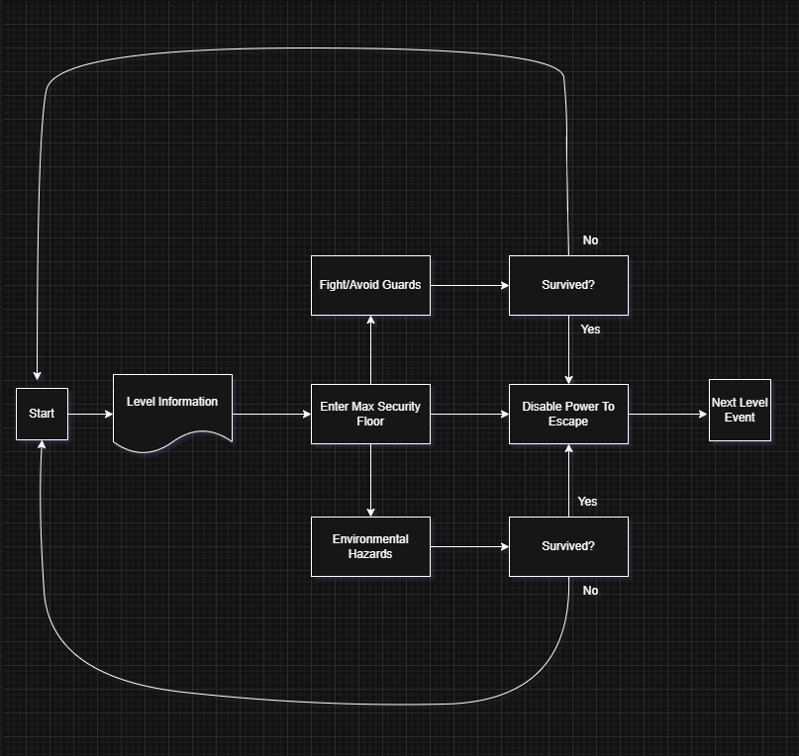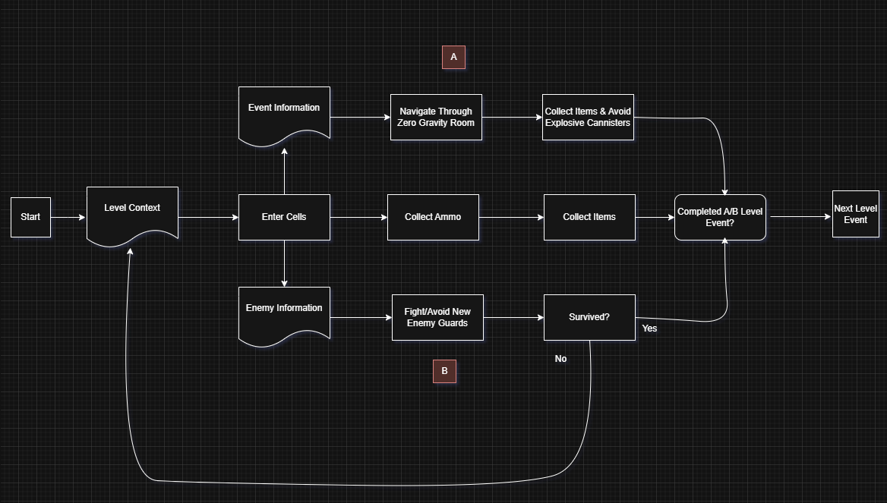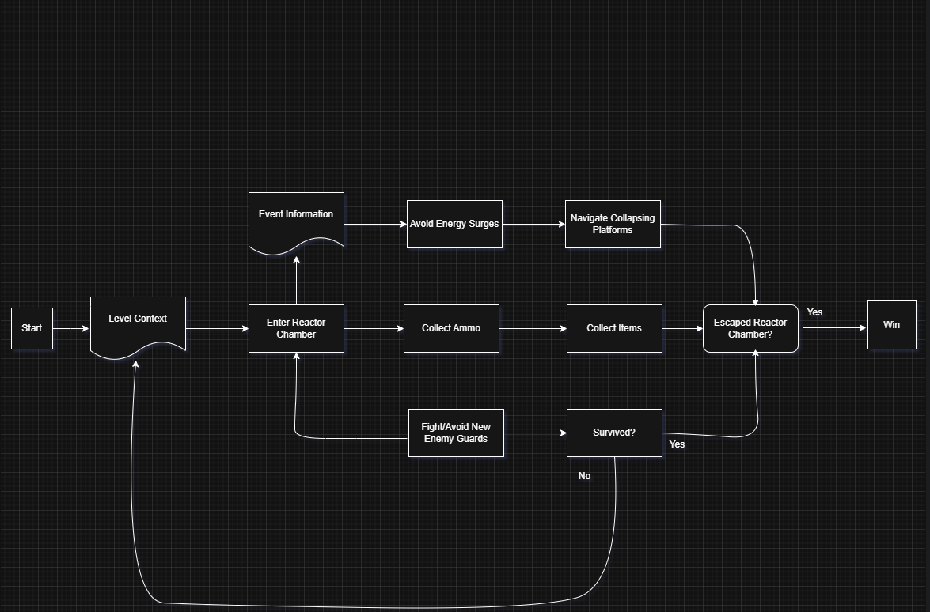

Planned Level Events
System | A1 | A2 | B | C
Movement | Essential | Essential | Essential | Essential
Shooting | Essential | Essential | Essential | Essential
Interaction | Essential | Essential | Essential | Essential
Low_Grav | No | No | Essential | Essential

Level Gameplay Events Details
Event | A | B | C
Title | Power Override | Zero Gravity Escape | The Ascent
Event Location | A malfunctioning part of the prison, dimly lit with flickering lights and broken machinery. | A spacious zero gravity area in the prison, with floating debris and broken machinery. | The top floor of Echelon 9, a vast reactor chamber with an energy core at its centre. Platforms and catwalks spiral around the core.
Situation  Where is the player, what are the relevant surroundings? | The player navigates through a security breach zone, filled with loud machinery and dim lighting. The door ahead is locked, and the player must override the security to progress. | The player enters a zero gravity zone where movement is altered and must navigate through floating obstacles to progress. | The player must ascend the chamber, avoiding collapsing platforms, energy surges, and hostile drones.
Problem  What does the player have to do or overcome | The player needs to deactivate the security override to unlock the door while avoiding or fighting patrolling guards. | The player must adjust to the zero gravity movement, avoid explosive hazards, and deal with malfunctioning guards. | The player needs to escape before the reactor fully melts down by reaching the escape pod or activating the hatch at the top.
Type of Challenge | - Environmental navigation (avoiding malfunctioning equipment).  - Combat challenge (fighting guards).  - Puzzle solving (deactivating the security override system). | - Navigation challenge (adapting to zero gravity movement).  - Environmental hazard (explosive barrels).  - Combat challenge (fighting guards). | - Environmental hazard (collapsing platforms, energy surges).  - Combat (fighting guards and aliens).  - Vertical navigation (climbing and jumping between platforms).
How is the Player informed  of the problem and solutions | - A computer terminal visible in the environment indicates the security override  - flickering lights near the override panel. | - Audio cues: loud alarms and explosions in the background suggest danger.  - Visual cues: the zero gravity environment is immediately obvious through floating debris. | - Visuals: energy surges lighting up the room, collapsing platforms, malfunctioning drones.  - Audio: sirens, reactor sounds, and drones’ movement provide clues.  - Objective markers guide the player towards the escape pod or the activation lever.
Solutions  the player can choose | - Deactivate the override system by solving a puzzle on the computer.  - player can choose to fight or avoid robotic guards while navigating the space. | - Use floating objects or platforms to help reach the next area.  - Avoid explosive canisters while dispatching guards or taking an alternate route. | - Jump to higher platforms and avoid surges.  - Fight drones or avoid them.  - Activate the escape pod lever to escape the reactor
Start Trigger | The player enters the malfunctioning security zone, with a quick prompt hinting at the locked door. | The player enters a room or hallway marked by zero gravity signage. | The player enters the reactor chamber and sees the collapse of platforms and the energy surges starting.
End Trigger | The player deactivates the security system to unlock the door. | The player reaches a new section, or the exit hatch is unlocked after navigating the floating debris. | The player reaches the escape pod or the hatch, activating the escape sequence before the reactor explodes.
Success Consequences /Rewards | - The player progresses to the next section.  - Potential loot or a temporary safe zone. | - The player moves forward with new movement mechanics learned and potentially new equipment.  - Health or ammo pickups. | - The player escapes the prison and moves to the next stage.  - Potential new gear or narrative progress.
Failure Consequences / Risks | - If guards catch the player, they respawn at a checkpoint with a health penalty.  - If the override isn't deactivated in time, reinforcements arrive, escalating combat. | - Floating too close to explosive canisters could trigger a deadly blast.  - Failure to avoid malfunctioning guards' results in respawn with health loss. | - Falling from the platforms results in death or respawn at a checkpoint.  - If the player is too slow, the reactor explodes, forcing a restart.

Level Map
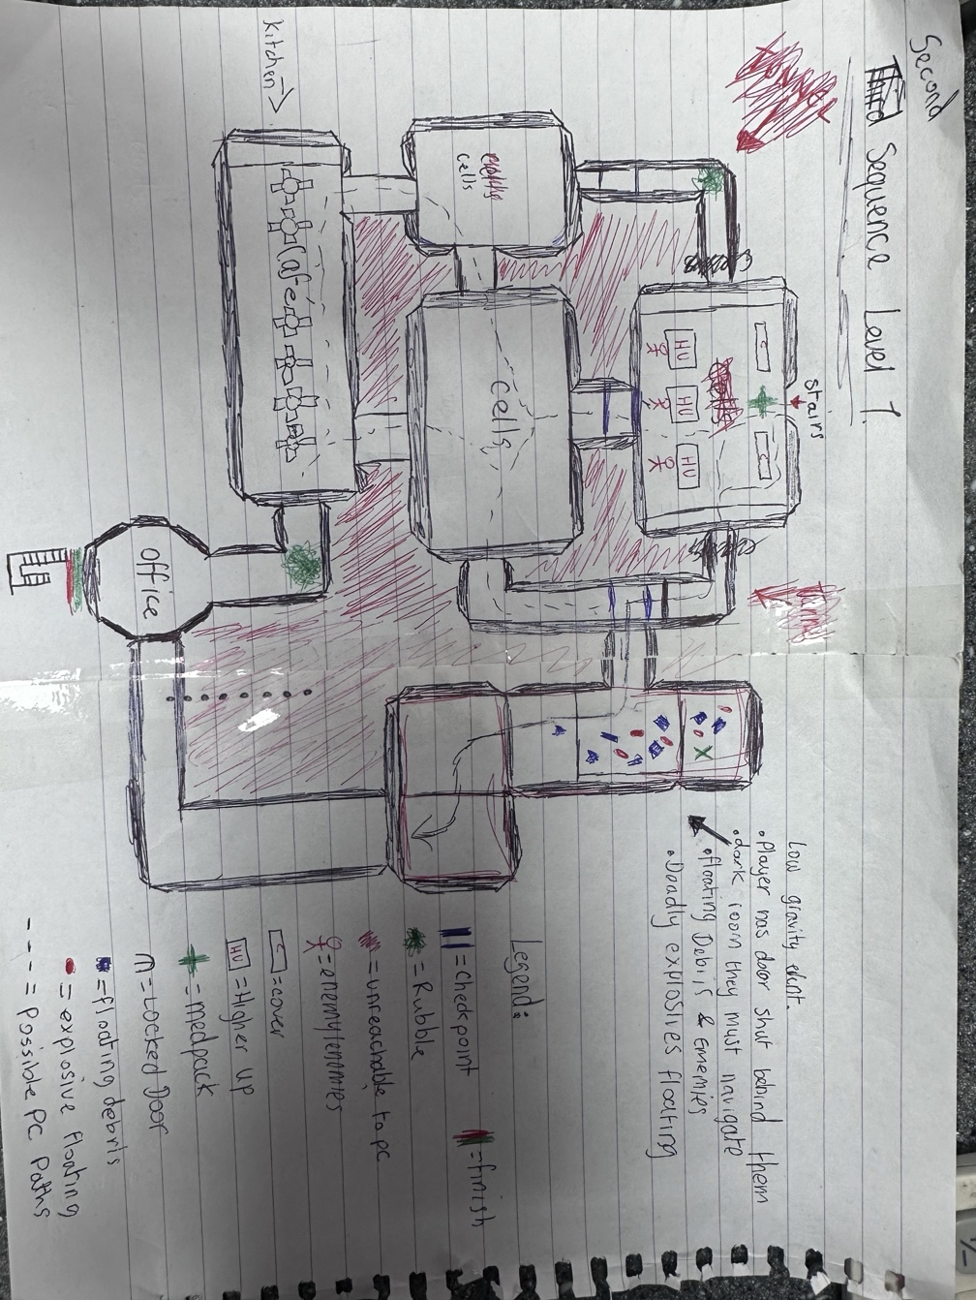

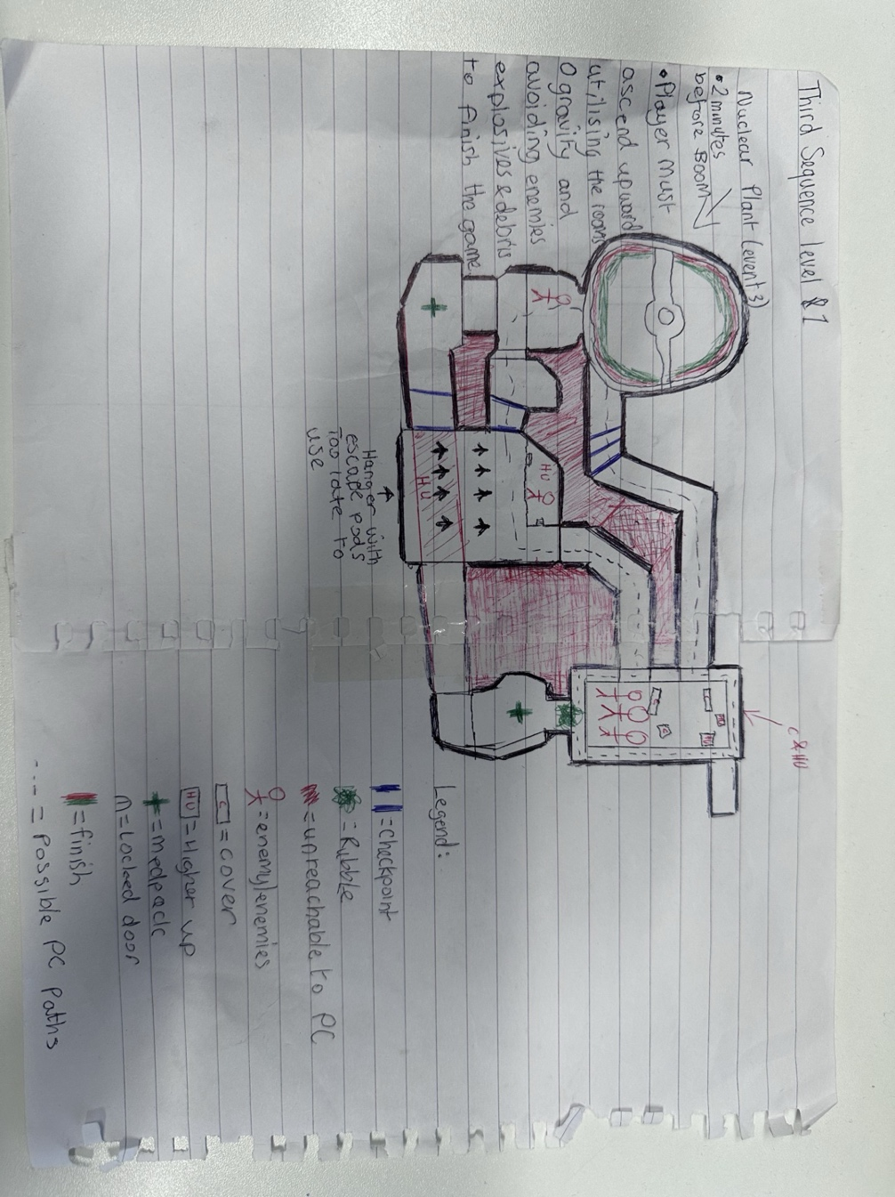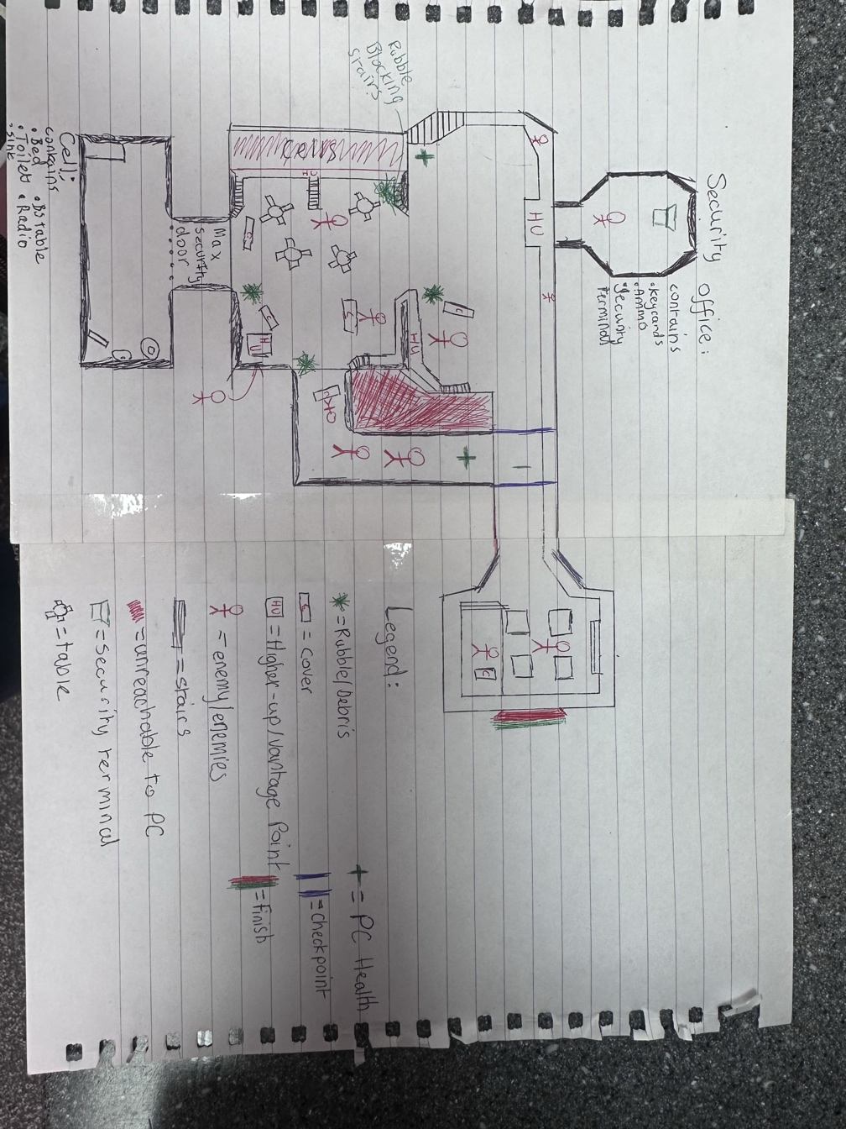

Puzzle Designs
Example Puzzle design
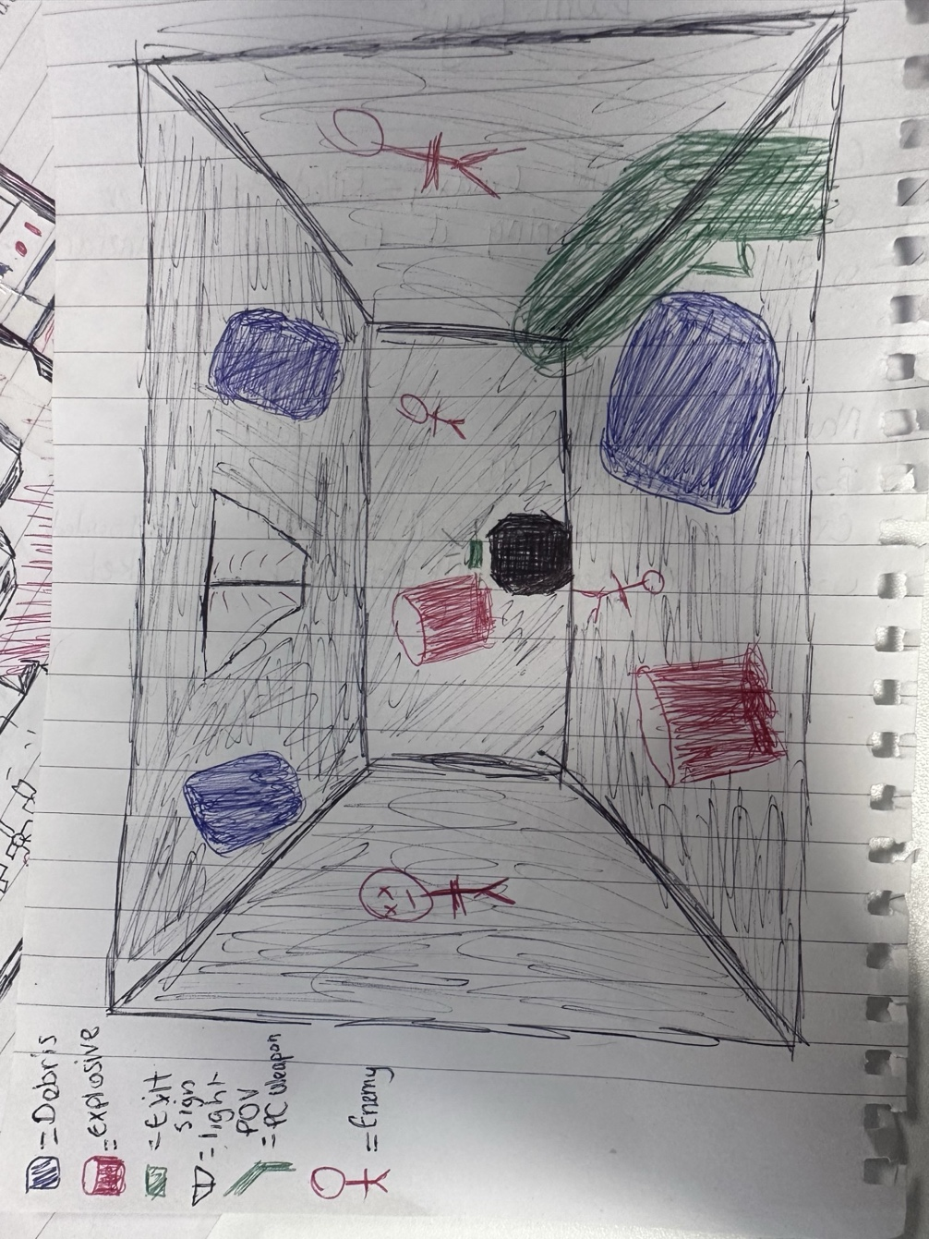
When the player enters the gravity room, floating debris, exploding barrels, and enemies will begin to spawn at a set rate in a dark environment, increasing over time. The player must navigate the room while facing the challenge of avoiding both explosive barrels and enemies, which can be difficult to tell apart from the floating debris in the darkness. (This can be seen in the map design section.)

Implementation, Testing & Problems
The original concept was set in a high tech intergalactic space prison, heavily inspired by sci fi shooters like DOOM. As development progressed, the vision naturally shifted toward a more grounded and oppressive setting, specifically a brutalist prison inspired by Soviet and UK architecture from the 80s to early 2000s. This change was made to emphasise a grittier, more atmospheric horror experience, which allowed for a deeper sense of dread and realism in the level design and environmental storytelling.
Functionality wise, several systems were iterated on to support this new tone. A low-gravity mechanic was implemented for specific level segments, allowing players to navigate through debris filled hazard zones in a unique way.
AI behaviour was adapted to accommodate two main enemy types: ranged human guards and aggressive melee based alien creatures, each offering different challenges. Additionally, interactable level events such as key triggered door systems were added to guide player progression and introduce pacing elements. This iterative process ensured the gameplay evolved naturally with the narrative.
Gameplay elements proved difficult to implement. Much time was spent trying to implement features in which did not end up in the result. One Example was A permanent low gravity feature in which the player could chose when or not to enable the gravity switch was developed however the environmental challenges and Enemy AI re development caused to be very time consuming which made the feature almost redundant. Hence why it was scrapped.

Key Game Objects Developed
Object: | Image  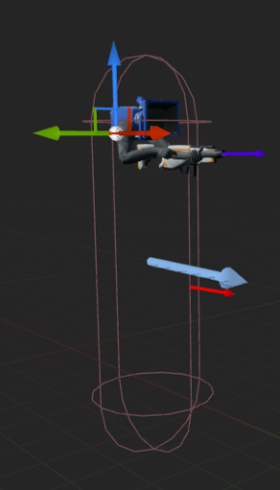
  Name: BP_FirstPersonCharacter
  Properties: InteractDotWidget, Interactionrange, InteractHitActor_REF, CanInteract?
  Functions: Interaction_Trace, Interact
Blueprint
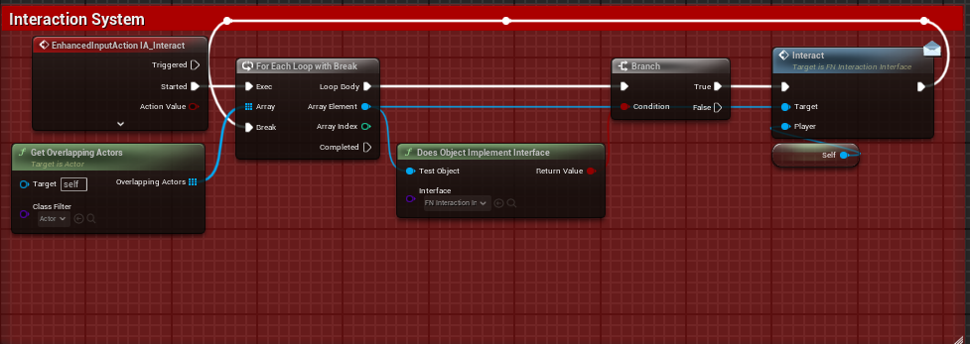
Description
This system is built upon a Blueprint Interface, this interface allows game objects which inherit said interface, can communicate with one and another with events which can be sent and received to execute blocks of code.
In this use case, this is on the BP_FirstPersonCharacter and uses a new Input Action created called “IA_Interact” which uses the “E” Key and the “X” button for Gamepads. Then it is called and a for each loop is created.
This loop will get all overlapping actors, will check if they implement the Interface mentioned earlier, if they do then it will interact with said object.

Object 2
Object: | Image
  Name: BP_FirstPersonCharacter
  Properties: IsCrouched?, MaxWalkSpeed
  Functions: Lean, Interaction _Trace, Interact, FootStepsTrace
Blueprint
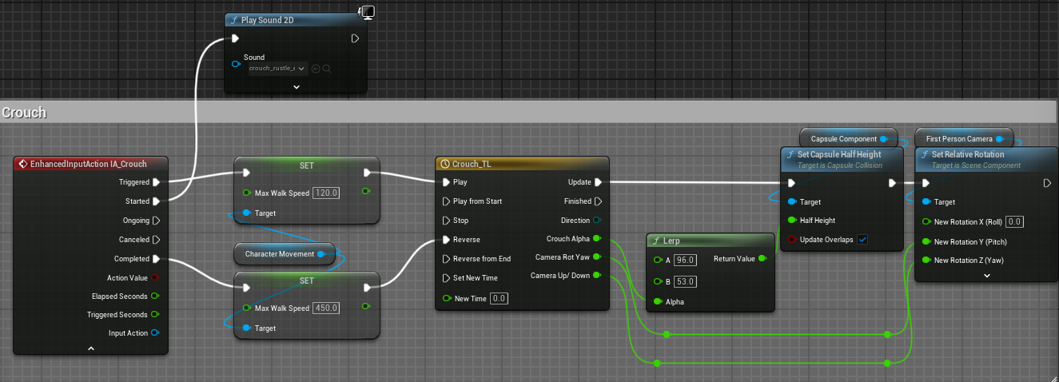

Description
This is a segment of code taken from the BP_FirstPersonCharacter. It enables the player to be able to crouch. How it is achieved is by creating a new input action and assigning it a key. Then once it is triggered it sets the players max walk speed to be a proportion slower. It does this by getting a reference to the players character movement component. It then plays a Timeline in which it lerps the players capsule height and the relative rotation of the first person camera accordingly.

Object: | Image  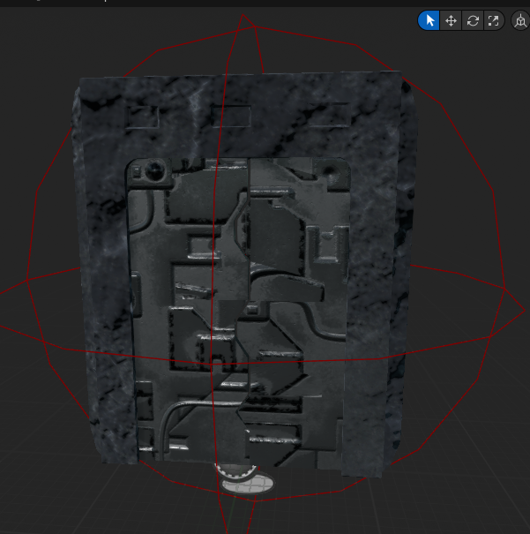
  Name: FN_Door_Interaction
  Properties: IsDoorMoving?, Opening?, IsFinished?
  Functions:
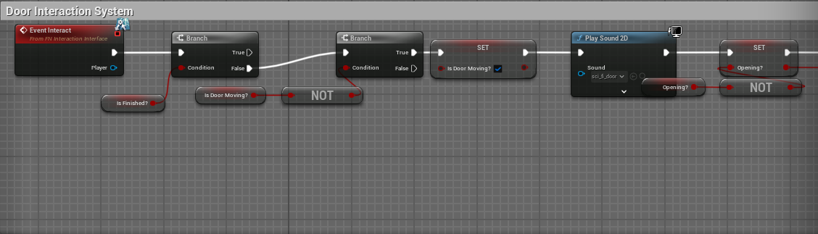
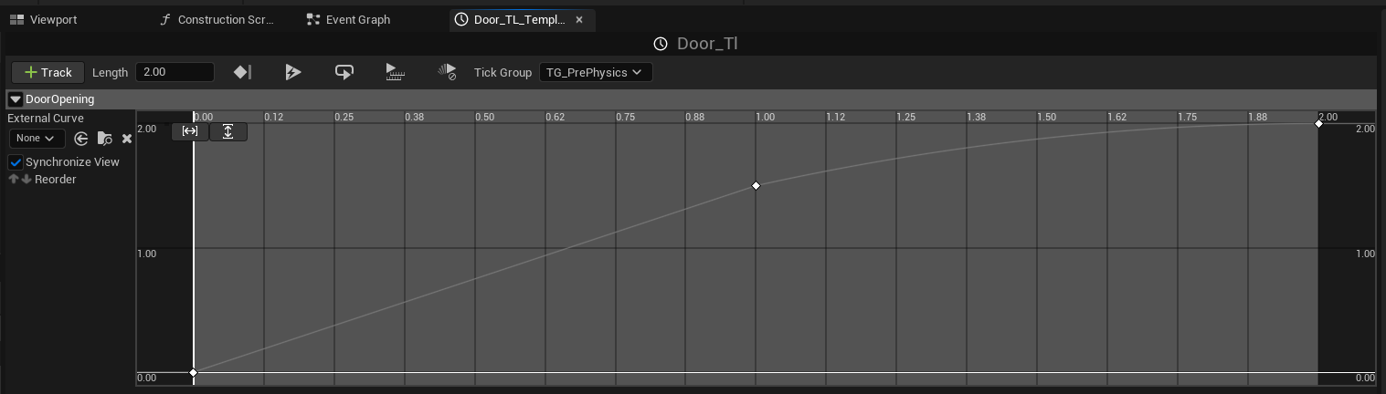The First Keyframe within the timeline has a value of (0,0), The second has a value of (1,1.5).
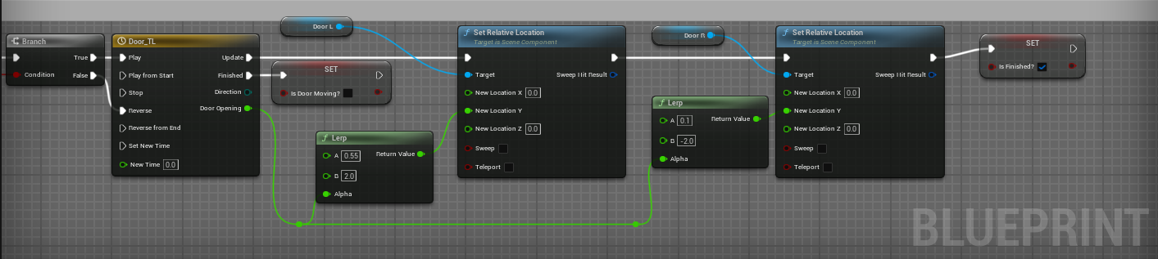
Description
This system is built upon a Blueprint Interface, this interface allows game objects which inherit said interface, can communicate with one and another with events which can be sent and received to execute blocks of code.
The Door Interaction System lets players interact with doors by pressing a key (E Key). It checks if the door is open or closed using branches. If closed, it plays a timeline to rotate the door open. If open, it rotates it closed. After the animation, it updates the door’s state. Built on an interaction interface, it uses timelines for the smooth movement and branches for logic.
Object:  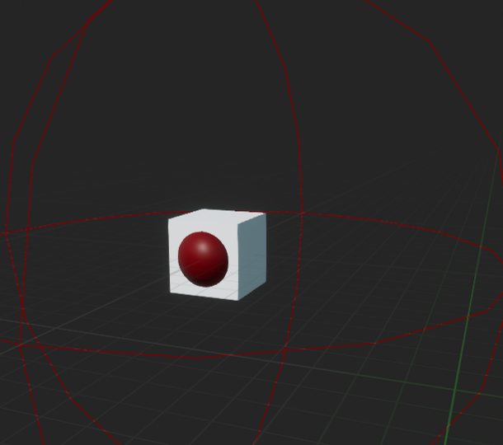 | Image
  Name: FN_Keycard
  Properties: IsDoorMoving?, Opening?, IsFinished?
  Functions:
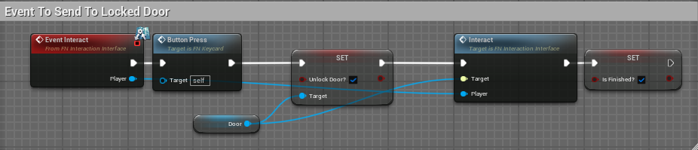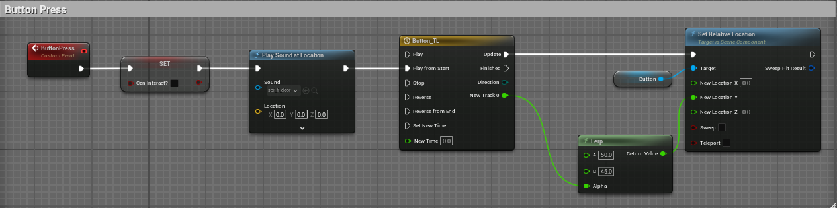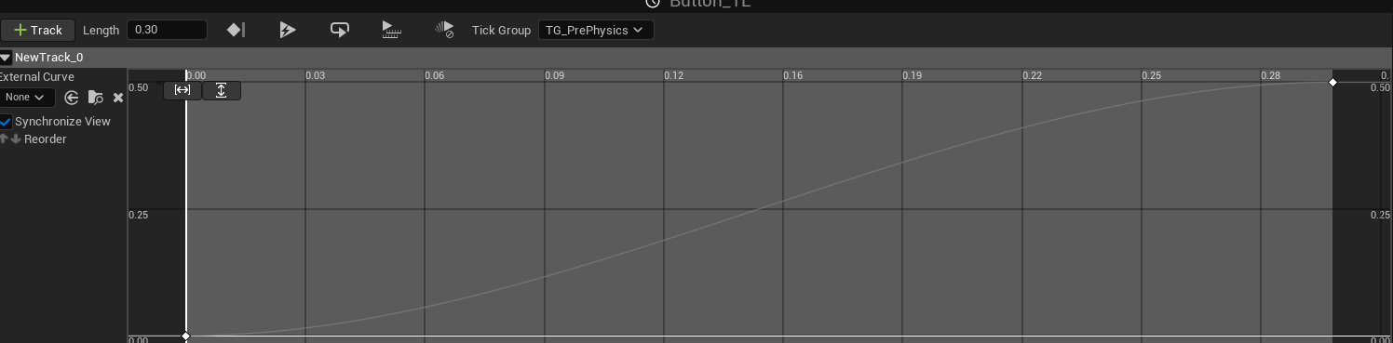The First Keyframe has a value of (0,0), the second a value of (0.3,0.5).
Description
Using a Blueprint interface, these two Game Objects are connected, and we can send events that other game objects with the same interface connected will listen out for such as “Event Interact” if the two game objects both share the interface, then the object will execute the button press, which accesses the components of the other game objects. This can be used to change and set variables.
So, in this example the button when pressed which is a Custom Event called “ButtonPress”, accesses the doors “Unlock Door” Boolean, it then Interacts with the door and sets it to be finished once completed.
The Button Press custom event, after it's called it will no longer be interactable as it sets its interactable Boolean to false. After, it plays a sound effect and plays a Timeline which lerps its position between two values, those being 50 and 45.

Object: | Image  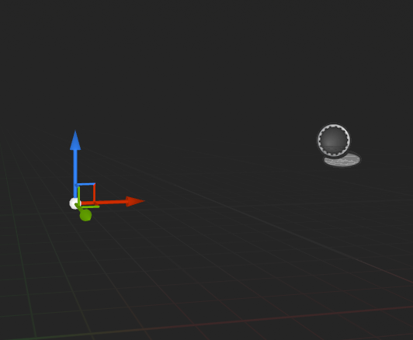
  Name: FN_Gravity_Room
  Properties:
  Functions:
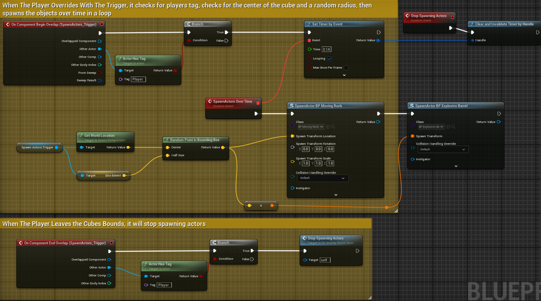
Description
When an actor enters the trigger, if it has a tag of player then the trigger box will begin to spawn items of 2 separate classes, “BP_Moving_Rock” which is the low gravity debris, and “BP_Explosive_Barrel” which is low gravity and explodes on contact.
It will spawn these items relative to the centre of the world position of the bounds of the trigger box, so it will try to find the absolute centre and spawn the items randomly within that. It will then stop spawning these items when the player leaves the bounding box.

Object: | Image  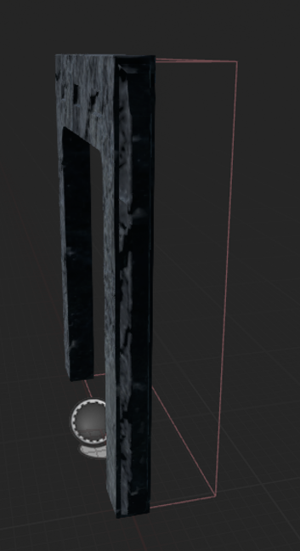
  Name: FN_Next_Level_Door
  Properties: LevelName, NextLevelTrigger
  Functions:
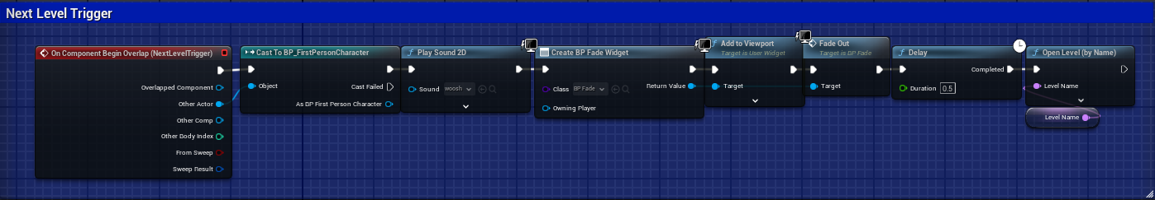

Description
This Game object will only execute the code if an actor overlaps with it, if so it will cast to the first person character and will play a sound effect, then it will create a Blueprint Widget for a transition (a fade animation), then will add it to the viewport, after that it will play the animation and add a slight delay before loading the level which is a public variable and editable within the scene.

Testing and Problems

Playtesting feedback
Tester | Feedback | Changes Made
Girlfriend | “Zero Gravity Room was confusing, debris obscured path” | Decreased debris size, added further lighting.
House Mate | “Guard Patrols felt too predictable” | Randomized patrol routes for Enemy Guards
Little Brother | “Too much to learn / overwhelming all at once” | Decreased number of mechanics to learn at once

Functional testing and playtesting of the game included gathering feedback from 3 play testers (girlfriend, housemate, little brother) to identify UX design flaw and gameplay imbalances.

Problems
Priority | Problem | Solution | Implemented
Low | FOV will not return to default value when stamina bar is depleted. | Add a condition check to determine if the stamina is less than or equal to zero, and if it is then changing the FOV back to the walk FOV | Solution has been added. Sprint FOV functions as intended..
Med | Guard AI’s shooting is very stagnant and only really functions of it is right in front of the player | Spend time developing a new Guard AI that has IK to correctly position its skeleton for movement and shooting | Solution has not been implemented yet as it has been deemed far too time consuming for the moment.
Low | Objects such as the Alarms and the Explosive Cannisters play enemy hit noises | Introduce a new function to my damage interface to allow for different enemy types so I don’t just have True/False as my damage sound conditions. | Due to time constraints, this was left undeveloped. However other objects that can be shot still function as intended so nothing is negatively impacted by leaving this unfixed.
Low | When player moves mouse too fast, Camera resets to centre of screen. | Get rid of my Spring Arm, or lower the Lag amount I have set for the spring arm. | This is a design choice for me, I plan to keep this in the game and just not have the player must directly 180 turns as that is only when it happens.
Med | Guard enemy AI will not shoot the player when in range | Create a new collision area that checks if the player overlaps rather than constantly checking if the player is within a range | Solution has been implemented, functions as intended, and Enemy AI Guards now shoot the player.

Critical Review
The BOOM GUY project successfully delivered a playable prototype with a clear visual style, working core mechanics, and strong thematic consistency. Key strengths of the project would include; the modular blueprint systems, particularly the door and keycard / button interactions and the games atmospheric world design, which combined retro style visuals with some environmental storytelling and sound to create tension and immersion.
However, the project was not without its challenges. Particularly the enemy AI was limited, with simple patrol logic and basic combat behaviour. Implementing more advanced systems like behaviour trees would have made encounters feel less predictable.
Scope management also became a major issue, features like the low gravity toggle were cut due to time and technical complexity, which could have been avoided with better planning. Limited playtesting meant some UX issues were only identified late in development.
Despite the limitations, the project shows a strong foundational knowledge of gameplay design and technical execution. The systems created are reusable and could support future expansion. The process also shoed responsiveness to feedback and a willingness to adapt and improve throughout development.

Conclusion

This project helped me grow my understanding of building gameplay systems in Unreal Engine and the value of planning around time and scope. I learned how to work with modular Blueprints, create interactive elements, and build levels that support player movement, combat and exploration.
Going forward, I’d aim to test more frequently, scope projects more realistically from the beginning, and improve enemy AI through more advanced systems. Overall, BOOM GUY gave me a clearer sense of how to balance creativity and structure in game development.

References

Bibliography

https://poly.pizza/m/jEw0ArUz9R

https://sketchfab.com/3d-models/sircom-esd-maestro-horn-speaker-5ce27fbad31443f4af82353a630b436d

Crouch_rustle_start.uasset
https://www.youtube.com/watch?v=5JhQIIPQaE0&ab_channel=SoundEffects%E3%83%84
FN_Shotgun_Shoot.uasset
https://www.youtube.com/watch?v=Ke346pSfUs0&ab_channel=mopig
https://www.youtube.com/watch?v=Ves2SnmMc34&ab_channel=SoundEffects

S_Stone_Mono(0,8).uasset
https://www.youtube.com/watch?v=CpS5Ex1Wx-4 Rain_Ambience.uasset

https://freesound.org/people/klankbeeld/sounds/607113/ AC_Ambience.uasset
https://sketchfab.com/3d-models/ps1ps2-locker-b1f3b98f56fe4d5cb2fb9a08cb27c805
https://sketchfab.com/3d-models/barrel-0aaa1d37b15f419a97a3368f09f058f5
https://www.mixamo.com/#/?page=1&type=Character

https://www.mixamo.com/#/?page=2&type=Character

Audio Assets

Appendices

UML Diagrams for Game Objects:

Class Diagram of Key Objects within the game.
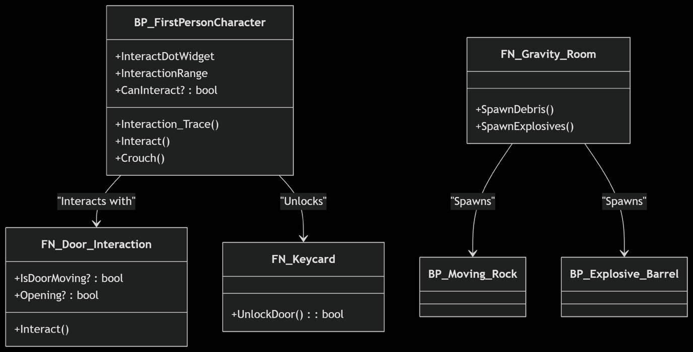State Diagram of the Door Interaction System.
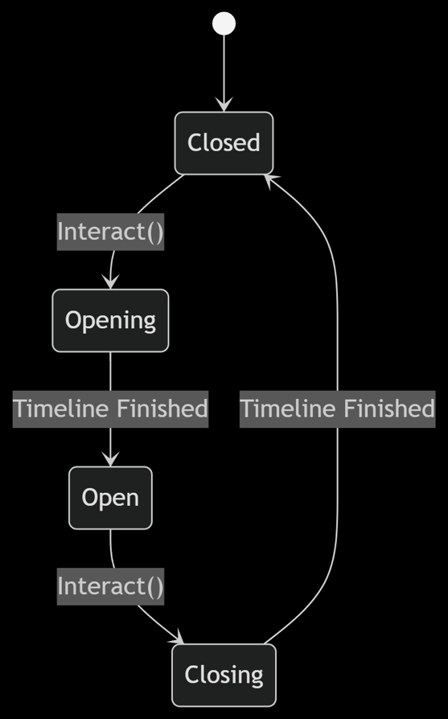

Walkthrough and Cheats
- Keyboard & Mouse
- W / A / S / D – Move
- Mouse – Look around
- Left Click – Shoot
- Spacebar – Jump
- C – Crouch
- Left Shift – Sprint
- E – Interact
- Gamepad
- Left Stick – Move
- Click Left Stick (L3) – Sprint
- Right Stick – Look around
- Click Right Stick (R3) – Crouch
- A Button – Jump
- X Button – Interact
- Right Trigger (RT) – Shoot

Level 1 Walkthrough
- Move forward out of the starting cell.
- Go up the first staircase to the left.
- Navigate across the upper cell block level.
- Descend the middle staircase to the lower floor.
- Encounter a guard, choose to fight or avoid.
- Choose one of two paths:
  - Right hallway – shorter, easier route with minimal enemies.
  - Left door – longer, harder route with multiple enemies, hazards, and debris
- Progress through either path until reaching a locked door.
- Head up to the nearby security room.
- Interact with the terminal to unlock the door.
- Return to the previously locked door and enter the next room.
- Encounter multiple guards, choose to run past or engage in combat.
- Exit through the next door and go up the staircase to complete the level.

Game Assets
Graphical Assets
Image | name | Used for | Sourced from
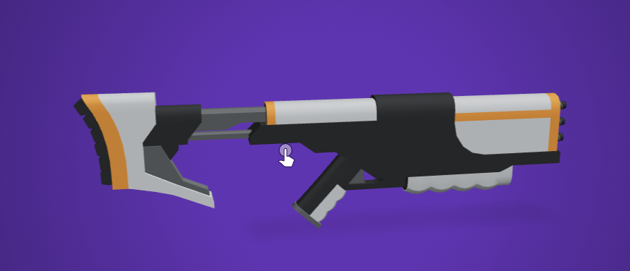 | Sci-fi Assualt rifle | PC Weapon | https://poly.pizza/m/jEw0ArUz9R
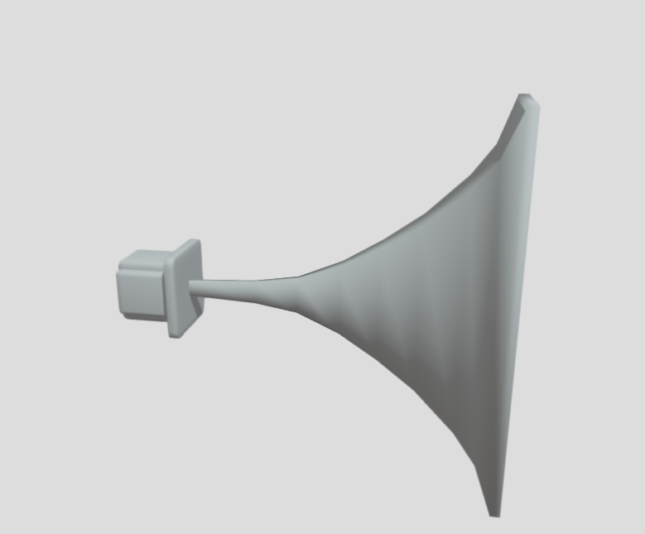 | SiRcom Horn Speaker | Speaker | https://sketchfab.com/3d-models/sircom-esd-maestro-horn-speaker-5ce27fbad31443f4af82353a630b436d
 | PS1 Hand Radio | Radio | https://sketchfab.com/3d-models/ps1-hand-radio-b5a0a3004a8340c690681043a467edc8
 | PS1/PS2 Locker | Locker | https://sketchfab.com/3d-models/ps1ps2-locker-b1f3b98f56fe4d5cb2fb9a08cb27c805
 | Barrel | Explosive Barrel | https://sketchfab.com/3d-models/barrel-0aaa1d37b15f419a97a3368f09f058f5
 | Vanguard | Guard AI | https://www.mixamo.com/#/?page=1&type=Character
 | Parasite | Alien AI | https://www.mixamo.com/#/?page=2&type=Character

Audio Assets
Sound | Used for | File & Source
Crouch | Crouching | Crouch_rustle_start.uasset  https://www.youtube.com/watch?v=5JhQIIPQaE0&ab_channel=SoundEffects%E3%83%84
Shooting | Shoot Noise | FN_Shotgun_Shoot.uasset  https://www.youtube.com/watch?v=Ke346pSfUs0&ab_channel=mopig
Footsteps | Footsteps | https://www.youtube.com/watch?v=Ves2SnmMc34&ab_channel=SoundEffects  S_Stone_Mono(0,8).uasset
Rain Loop | Sprinkler Ambience | https://www.youtube.com/watch?v=CpS5Ex1Wx-4 Rain_Ambience.uasset
Horror Ambience | Ambience | https://freesound.org/people/klankbeeld/sounds/607113/ AC_Ambience.uasset
Reactor Core | Reactor Core Ambience | https://freesound.org/people/antwerpsounddesign/sounds/545953/ Reactor_Core_Ambience.uasset

