University of Brighton
Computer Games

CI410 - Game Design & Development 2024 -5
Coursework: 3D Unity Game
3rd Person Action Arcade Game
Module Leader: David Dorrington

Student: Finley Nye
Date: 12/12/2024

Contents

Contents 2
Introduction 3
Game Idea 4
Working title 4
Concept statement 4
Genre 4
Influences 4
Target audience 4
Player experience 4
Visual style 4
Mini Mood Board 5
Game rules 5
Objectives and progression 5
Core Loops 5
Accessibility 5
Summary of Overall Game Design Decisions 5
Game Design & Implementation Decisions 6
Game Flow with Events 6
Level Events & Gameplay Systems 6
Level Gameplay Events Details 7
Level Map 8
Puzzle Designs 10
Implementation, Testing & Problems 11
Problems 11
Critical Review 12
Conclusion 12
References 13
Bibliography 13
Theoretical Research 13
Appendices 14
Walkthrough and Cheats 14
Game Analysis 15
Game Assets 16

Introduction
This document covers the concept and development of Arc of Isles. It covers topics from visual style, player experience to gameplay mechanics and Design Pillars.

Game Idea

Working title
Arc of Isles

Concept statement
A puzzle platformer set in a bright, vivid, and stylised world. Includes combat mechanics for engaging with puzzles and enemies.

Genre
Arcade, Puzzle

Influences
- My game is inspired by The Legend of Zelda: The Wind Waker and It Takes Two. It features varied, dynamic combat mechanics, and the stylised look reflects the games I grew up with, especially Wind Waker.
- I am also a huge fan of how enemies behave in the Super Mario Galaxy series. I plan to take inspiration from this to develop my own unique style of enemy behaviour.
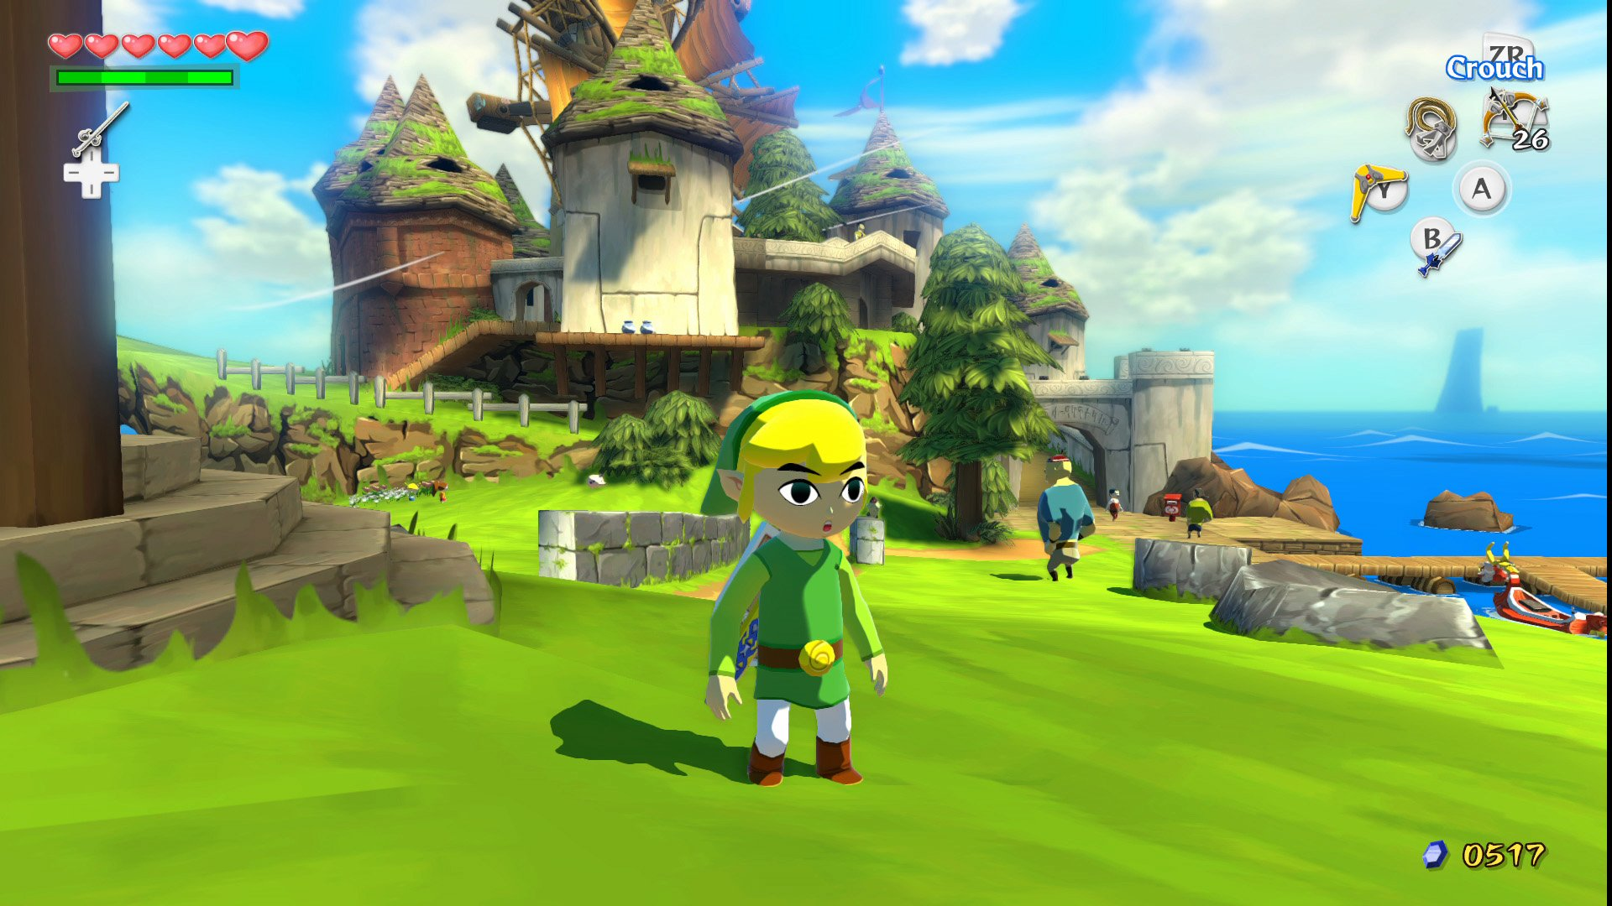 | 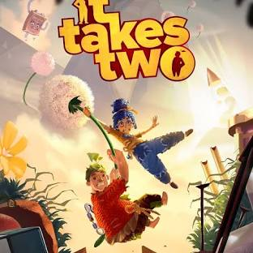
The Legend of Zelda: The Wind Waker, 2002, Nintendo | It Takes Two, 2021, Hazelight Studios
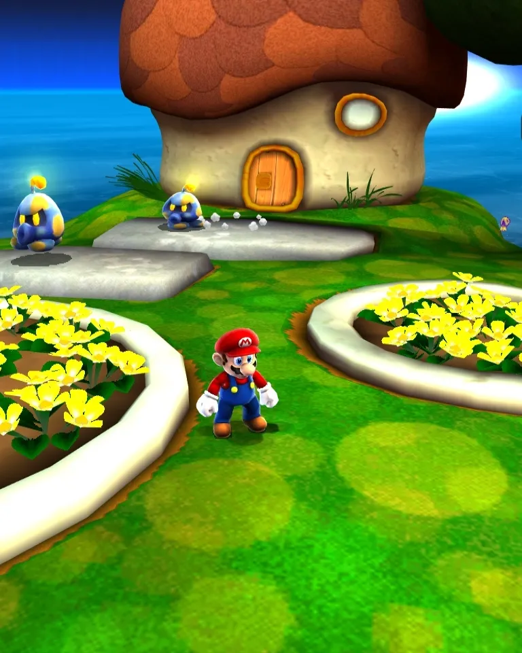
Super Mario Galaxy, 2007, Nintendo

Target audience
The target audience is players aged 10–14, and the desired ESRB rating is 7+ or 10+. The game is designed to be played by all genders.

Player experience
The player controls a small, stylised character with a sword and shield, resembling a mix of Mario and Link. The controls aim to be responsive, hopefully mirroring the feel of that Mario series.
The player explores floating islands connected by small bridges or moving platforms. They solve puzzles to reach new areas and defeat enemies to unlock stat upgrades, like max health, weapon damage, and max speed.
The setting is a bright, vivid, and stylised open space with a linear world design, inspired by The Legend of Zelda: Wind Waker.
Hopefully, the game’s bright, stylised colours like blue, white, and bright green are intended to create a calm atmosphere, reinforcing that the player feels relaxed, not overwhelmed.
4 Design Pillars:
- Puzzles include locked doors with keys, blood locks, and platforming challenges.
- Combat mechanics include a light combo (5 hits), a special attack, and a heavy combo.
- Enemies are designed to be simple.
- To have immersive and great feeling sound design

The game will alternate between puzzles, combat, and exploration to keep the player engaged. Players will solve a puzzle, fight, explore, and then face another puzzle and combat, delivering a good flow of gameplay that is not too stressful.

Visual style
bright, calming, fantasy, stylised, Tailor-made for a younger audience.
The game is designed to be played by a younger audience. Enemies are designed to be enough to make combat engaging and rewarding, without adding too much difficulty, so players can enjoy both combat and puzzle challenges without stress.

Mini Mood Board

List of Images
https://pxhere.com/en/photo/626041 - Sky
https://www.deviantart.com/yongl/art/Floating-Island-Of-Innisfree-274675709 - Floating island
https://www.rawpixel.com/image/4021566/american-robin-woods-background - Bird image
https://www.deviantart.com/olgola/art/Portal-1068779436 - Floating island stylised
https://www.deviantart.com/saimoomsab/art/Low-poly-paradise-1009221343 - Low Poly Forest environment

Game rules
Players must stay on the islands to avoid falling into the death barrier, use their mouse to navigate more efficiently, and complete the NPC's first quest to prepare for tougher enemies, all within a consistent stylised Poly art world with vibrant and grungier colour palettes.

Objectives and progression

Goals:
- teach basic movement
- teach basic combat mechanics with/without AI real-time example
- teach basic platforming mechanics
- introduce a more complex platforming challenge
- complete level 1
Objectives:
- complete NPC quest
- learn movement
- learn combat mechanics
- solve a puzzle
Challenges:
- balancing enemy AI to avoid overwhelming players
- managing the difficulty of moving and falling platforms
- Creating a fair but punishing combat system

The player progresses by learning all mechanics in the first level through practical examples, including enemy AI and puzzle platforming, presented in a non-intimidating way.
The short-term goal of the game is to teach players the basic mechanics, I would do this by implementing an NPC which rewards them in level 1 with a stat-boosting cape after basic combat training.
The long-term goal is to provide a fun, but moderately challenging gameplay loop, mixing puzzles like blood locks and riddles with snappy combat mechanics. Players either must fight their way through challenges or use their brains to solve puzzles ahead.

Core Loops
The main gameplay loop involves exploring islands, solving puzzles like blood locks and riddles, and fighting simple enemies.
there are also smaller loops, such as:
- Platforming, where you jump across moving or falling platforms, sometimes needing quick thinking or retries due to player death.
- Combat, where enemies respond to your attacks with damage or death, rewarding you with progress.
- Quests and puzzles, where completing tasks unlocks new items or tougher challenges

These loops help keep players interested by giving rewards, a sense of progress, or chances to learn from their mistakes.

Accessibility
I could potentially make my game safer and accessible by making text size adjustable or providing options for other fonts, including a difficulty selection in a settings menu for varied skilled players. I could also implement key bind remapping, which would also increase the accessibility.
Lastly, I could include visual audio cues for hearing-impaired players as I plan to have audio play a massive part.
https://docs.microsoft.com/en-us/windows/uwp/gaming/accessibility-for-games

Summary of Overall Game Design Decisions
Arc of the Isles is a whimsical adventure where players use their incredible swordsmanship and quick thinking to fight enemies and solve basic yet engaging puzzles.
Set within a beautifully stylised low poly world, the game features vibrant landscapes, atmospheric environments, and memorable exploration. From bright fields to dark dungeons, it is a charming mix of fun and adventure.
Element | Detail
Design Pillars | Fun but fair combat, Puzzles that are somewhat simple, immersive sound design
Player Experiences | Mystery, Relaxed, Calming
Overall Goal of Game | Defeat the Boss
Objectives | Snappy responsive movement / combat mechanics
Main Gameplay Challenges | Timing between attacks, platforming puzzles
The Player Character(s) | Young boy with a sword and shield
Core Gameplay Styles | Third Person, Adventure, Platforming, Puzzle
World | fantasy feeling
Environment Style | Stylised, Contradicting
Key Locations | The Levels within the game
Art Style | Stylised Low Poly Art Style

Game Design & Implementation Decisions

Game Flow with Events
The gameplay will guide the player through their first challenge by encouraging them to use their attack abilities. They will need to navigate the islands solving platforming puzzles and completing NPC Quests and killing enemies

Level Events & Gameplay Systems
System | Level 1 | Level 2 | Level 3
Movement | Essential | Essential | Essential
Sword Combo Attacks | Option | Essential | Essential
Jumping & Double Jumping | Essential | Essential | Essential
Interactable Objects | Essential | Option | Essential
NPC | Essential | Optional | Unnecessary
Puzzle Systems | Essential | Essential | Optional

The systems in my game that will be crucial for most gameplay events are:
- Interaction System: allows the player interactions with NPCs and objects.
- Enemy AI System: Introduces challenges during exploration.
- Platforming System: Adds traversal mechanics for obstacles and moving platforms.
- Combat System: Allows the player to defeat enemies or open chests or explode barrels with up to five-hits.

Level Gameplay Events Details
Event | A | B | C
Title | Level 1 | Level 2 | Level 3
Event Location | Floating Islands | Dungeon | Castle
Situation  Where is the player, what are the relevant surroundings? | The player is on a floating island, they need to navigate their way through the islands | The player is spawned into dungeon, they need to reach the end of the dungeon to complete the level | The player spawns on the same island they finished level one in to indicate the leaving of the dungeon.
Problem  What does the player have to do or overcome | Platforming challenges, NPC Quests, Eliminating Enemies | Parts of the dungeon are locked away stopping progression unless the puzzled for said area is solved | The player must overcome platforming challenges and to defeat the boss to complete the game.
Type of Challenge | Combat, Puzzle, Quest | Puzzle, Combat | Combat, Platform
How is the Player informed  of the problem and solutions | With 3D GUI Elements dotted around the beginning area of the 1st level.  Combat training dummy at beginning of the level to demonstrate basic combat.  NPC informs the player where to go for quest. | Chest they are prompted to hit using their special ability.  The locked away parts of the dungeons are doors that when interacted with display a message which informs the player, they need a key.  If the player hists the chest they receive a key | The player is informed they are about to fight the boss with some guided text and an island where the npc used to reside is now vacated with text about the boss itself.
Solutions  the player can choose | Using their combat abilities, use their superior movement capabilities | Hit the chest, get more information to progress | To use their combat abilities to defeat the enemies or to use the barrels the boss throws at the player to hurt the enemies and boss.
Start Trigger | Starting the game | Starting the level | Starting the level
End Trigger | Entering the tower | Unlocking the Final Door | Eliminating the boss
Success Consequences /Rewards | Proceeding to Level 2.  Receiving a reward from the NPC which gives a stat boost | Proceeding to Final Level. | Completing the game
Failure Consequences / Risks | If the player dies, they are respawned to a set amount of respawn points | If the player loses their key. They would have to restart the level, stopping progression | If the player dies their progress is not reset, however the difficulty of this level is much higher so it may be more frustrating.

Level Map

Puzzle Designs
the plan for the puzzle is for the player to walk within the blood lock room. When they enter the doors close behind them locking them in.
then enemies begin to spawn, and the player is trapped within the room, respawning there if they die. The doors would not open until all enemies are defeated.

once doors open. two chests spawn. one in the top corner of the bloodlock room on the second floor (which is walkable once the bloodlock ends). The other in the final room in the dungeon.
one chest contains a key that opens the final door within the level, the other contains a riddle on the key's whereabouts. without opening this chest, the progression to the final level is blocked.

after testing, the second floor is now walkable from the beginning as the items in the chest have swapped so the riddle is now in the dungeon and the key in the bloodlock room, this helped
improve the flow of the gameplay and gives the player a longer time to solve the riddle and complete the level.

Implementation, Testing & Problems

The process of developing the original game idea began with a clear vision to create an engaging arcade puzzle platformer that balances combat with exploration and puzzles.
the initial brainstorming phase began with focusing on the mechanics that would define the game such as; platforming challenges, combat systems, puzzle designs and a player controller like Mario and The Legend of Zelda.
Early prototypes were built to test player movement, combat responsiveness and puzzles mechanics. This phase helped identify the areas that needed adjustment or fine tuning.
Regular playtesting sessions with peers, both within and outside of university, in early development helped improve functionality with the player’s character controller.
For example, after feedback, I slowed the character down to make the gameplay more focused on exploring and puzzle elements. This turned out to be a beneficial change, as later playtesting sessions showed that players moved more thoughtfully through the environment and engaged better with the challenges.
when redesigning, to improve player engagement the flow of gameplay, overall gameplay flow was redesigned to alternate between combat, puzzles and exploration rather than all three at once which was seen as too overwhelming.
additional functionality such as a boss ai and NPC dialogue system that respond to player actions, this improved the immersion, interactivity and enhanced the overall gameplay loop within the game.
the redesign process was mainly guided by playtesting feedback. For example, a more recent build was published and sent to a family member within the target audience to play and the feedback I received was overwhelmingly positive, they noted the world was to their liking and enjoyed the interaction capabilities within the game.

Problems
Priority | Problem | Solution | Implemented
Low | Character Controller:  The characters collision gets stuck on edges due to constant gravity application and the capsule shape | Improved physics handling  Ground Detection Enhancement | Need to research problem
Low/Med | Camera Controller:  Abrupt camera movements, especially noticeable during rotation. | The use of Vector3.SmoothDamp helps, but the fl_rotationSmoothTime parameter might need fine-tuning.  ensure consistent frame rates to avoid variations in smoothing. | Solution has been implemented within timescale (using SmoothDamp), but further refinement might be needed.
Med/High | Camera Controller:  Camera clipping through game objects when close to walls or barriers. | Implement collision detection with either “Phyiscs.Linecast” or “Physics.SphereCast” to check for obstacles between the camera and the Player Character.  Adjust the camera's position to avoid clipping. | Need to research problem/Could not have been applied in current timescale.  The script calculates a fixed offset from the target. It does not account for obstacles.  Could not have been implemented due to time constraints.
High | Boss AI:  The Bosses State Machine Complexity. The state machine is quite complex and could become difficult to manage with more states or complex transitions | Use interfaces or abstract classes to define the interactions with other components.  This will allow to easily swap out different implementations or reuse the script for other enemies. | Partially Implemented.  The script uses events for some interactions,  but other dependencies could be separated further.
Low/Med | Boss AI:  The Boss AI script handles a lot of different responsibilities, including movement, attack logic, animation control, and even some of my sound effects.  This can make the script less modular and harder to maintain. if I wanted to expand on it | breaking down the script into smaller, more focused scripts.  separate scripts for movement, attack logic, and animation control.  This would improve code organization and make it easier to modify or extend the boss AI behaviour. | Solution has not been implemented due to time constraints and the script being very complex to debug.
Med | Health Scripts (PC, NPC, Boss)  The enemy and player health bar creation are less flexible than using a prefab. It also makes it harder to customise this health bar when its being hard coded | Create a prefab for the health bar and instantiate it in the Start method.  This allows for easy customization and reuse. | Needs Refactoring
Low | Health Scripts (PC, NPC, Boss)  The health bar rotates to face the player. This is my intention to have it to look like this however it can look odd in some situations. | Consider if the rotation of the health bar is needed.  use a different approach such as billboarding or only rotating on the Y axis. | Design Choice
High | Explosive Barrels:  The update function in this script uses “Physics.OverlapSphere” every frame whilst the attacking Boolean flag is true on the player.  This would become especially apparent if many barrels were in one scene,  This could lead to significant performance issues leading to noticeable frame rate drops or lag. | Change the method of detecting damage from the player,  Instead of using physics to constantly check for the player. I could use an event system.  The barrel would subscribe to the event and only perform necessary actions when the event is fired.  This would be the most efficient use case method for my barrel system however it requires a lot more setup. | Due to time constraints and the complexity of the system change, this will not be implemented.  This is something I will consider if I were to ever come back to this project but the method currently being used after testing  Doesn't impact performance unless there are a ridiculous number of barrels in the scene which I do not plan to do.
Med | NPC:  The script uses the same responses for each dialogue state.  This can make interactions feel repetitive. Especially if you interact during the in-progress state. | Use a list of strings to store multiple possible dialogue responses for each state.  Then randomly chose a response from the list.  This would make the NPC feel more alive and make interactions feel more fluid. | Due to time constraints, this was being planned to be something I was going to have a go at.  However, the NPC only really had one use case in the game being in level 1, so I thought it useless to expand on the system.
Low/ Med | NPC:  The Start() method uses “GameObject.Find(“Cloak03)” to find the players characters cape.  This is a resource expensive operation in Unity and can be slow especially if there are many objects within the scene. | Use a public Game Object variable and assign the cape in the inspector. | Partially Implemented.

Critical Review
- The level design in the first world introduces the games core puzzle, combat and movement mechanics. Players are gradually introduced to new elements throughout the level ensuring a smooth learning curve.

- The combat system gives great visual and audio feedback, making each attack feel impactful. Weapon trails, impact particles, and clear swing and hit sounds for different enemies and objects make combat satisfying. The player’s attacks, like a five hit combo and a special attack along with the use of environmental elements like explosive barrels, create plenty of options during combat.

- While the basic enemy AI was intentionally simple for early game introduction, its predictable behaviour makes combat encounters too easy. The enemies consistently charge directly at the player and perform a single melee attack. To improve, I could implement more varied enemy behaviours, such as flanking, ranged attacks, or different patrol patterns. This would create more challenging combat encounters.

- Due to time constraints, I wasn’t able to fully develop the NPC interaction system to include multiple dialogue options for each state or add more advanced enemy AI behaviours, like dynamic patrolling, ranged attacks, and different enemy types. This made the gameplay simpler than I had originally planned. Also, adding the puzzles into the levels was harder than expected, so some of them feel a bit out of place.

- The minimalist GUI looks nice, but it doesn’t give players enough context. This makes it harder for them to know what their goals are. To improve this, I could create a more helpful GUI that shows key elements without making the screen feel too busy.

- The game doesn’t have enough puzzles to really call it a "puzzle" game. The few puzzles, like the riddle, blood lock, and platforming challenges, are quite simple and don’t feel connected to the main gameplay. To improve, I could add more complex puzzles that fit better with the game’s core mechanics, like movement and combat. The aim would be to make puzzles that get players thinking in creative ways.

- To make the gameplay better, I’d focus on three main areas; improving enemy AI to make combat more dynamic and challenging, creating puzzles that are more connected and engaging, and expanding the NPC interaction system to add more depth to the story and player involvement.

Conclusion
- This project taught me how important it is to manage my time in a structured way, keep the scope realistic, and start prototyping early. I learned that it’s better to create a smaller, polished game than a bigger, unfinished one. I originally planned for the game to be simple with a few systems to show in my portfolio, but the project grew out of control because I didn’t plan well during development.

- The main lessons I took from this project are the importance of good pre production planning, clear player feedback and using playtesting to improve the game through iteration. I learned more about basic AI principles, how to integrate different gameplay elements, and how sound and design can help give players clear feedback. I also got better at C# by trying out more advanced tools and ambitious programming ideas, improved my overall skills in Unity, and deepened my understanding of loops and game design concepts by applying them in my project.

References

Bibliography
https://docs.unity3d.com/6000.0/Documentation/ScriptReference/GameObject.Find.html - Unity Documentation
https://pxhere.com/en/photo/626041 - Sky
https://www.deviantart.com/yongl/art/Floating-Island-Of-Innisfree-274675709 - Floating island
https://www.rawpixel.com/image/4021566/american-robin-woods-background - Bird image
https://www.deviantart.com/olgola/art/Portal-1068779436 - Floating island stylised
https://www.deviantart.com/saimoomsab/art/Low-poly-paradise-1009221343 - Low Poly Forest environment

Theoretical Research
Source: Title, Date & Author (Online Documentation) | PLEASE use a Unity SOUND MANAGER! Small Hedge Games, 14th January 2021. https://www.youtube.com/watch?v=g5WT91Sn3hg (Accessed: 3rd December 2024)
Source’s Concept / Theory & Key Relevant points
The tutorial gives a clear guide on how to create a sound manager in Unity. It explains how to handle audio clips, organise sound effects effectively, and boost performance by cutting out redundancy. The focus is on using one script for playing sounds through a global manager, which makes it easier to maintain.

Application to your Design
The ideas from the tutorial were used to set up a sound manager in the game, making it simple to manage and trigger sound effects. This boosted efficiency in handling audio, ensuring that sounds are spot on and easy to control.

Source: Title, Date & Author (Online Documentation) | The Legend of Zelda: The Wind Waker.  https://www.nintendo.com (Accessed: 5th December 2024).
Source’s Concept / Theory & Key Relevant points
The Legend of Zelda series is known for mixing exploration, puzzle solving, and combat in bright, fantastical worlds. It’s all about open world design, picking up items to progress, and balancing combat with non combat challenges. The games often feature stylised, super colourful art and sound design that immerse the player fully.
Application to your Design
The Legend of Zelda directly influenced the design of Arc of the Isles, even down to the main character’s design. The biggest similarities, though, are in the puzzles, exploration, and combat, all set within a colourful, stylised aesthetic world.

Source: Title, Date & Author (Online Documentation) | Unity Technologies (2024). "GameObject.Find Method."  https://docs.unity3d.com/GameObject.Find.html (Accessed: 12th December 2024).
Source’s Concept / Theory & Key Relevant points

The documentation explains how the GameObject.Find method works to locate objects in a scene by name. Key points include performance considerations and use case for dynamically finding objects in runtime.
Application to your Design

This was helpful as it elaborated how to locate specific objects in the scene. For example, it was used to locate the players cloak when interacting with the npc.

Appendices

Walkthrough and Cheats

Basic Controls:
  - Movement: Use the WASD keys to move.
  - Jump: Press the Spacebar to jump.
  - Attack: Left click for a light sword attack.
  - Special Attack: F for a heavy sword attack.

- Start: You begin on a small floating island. Explore the area.

- Learn Basic Movement: Move around using WASD.

- Combat Tutorial: Approach the combat training dummy and press Left click to perform a sword combo.

- Platforming Mechanics: Approach the moving platform and attempt to land on it.

- Combat Enemies: Fight simple enemies as you move across the islands. Use sword combos to defeat them.

- NPC Interaction: Speak to the NPC near the campfire and house to start your quest (press E to interact). The NPC will guide you ask you to go retrieve their bag and they will reward you.

- Stat Boost: After completing the NPC Quest, you'll earn small stat boost in the form of a cape.

- Progress to the Next Area: Complete the set of platforming challenges and reach the tower.

- Final Objective of Level 1: Once the tower has been reached, you approach the door. It asks for a key. You are then prompted to use your ‘F’ attack to open the chest revealing a key and progression to level 2.

Game Analysis

Game Influences
Game | Overview | Why is it interesting?
The Legend of Zelda: The Wind Waker | A vibrant action-adventure with island exploration, puzzles, and combat. | Influenced my world design ideas, puzzle mechanics, and exploration style
It Takes Two | A cooperative platformer blending diverse mechanics. | Its varied gameplay loops influenced my approach to puzzles, combat, and level design.
Super Mario Galaxy | A 3D platformer with creative gravity-based puzzles. | Its platforming and environmental exploration inspired the gameplay mechanics in my game.

Genre
Common | Unusual | Rare
Puzzle Platformer | Combat Exploration | Perspective based Puzzles
RPG | Time Manipulation | Asymmetrical Gameplay

Mechanics
Common | Unusual | Rare
Walking / Sprinting | Dynamic World | Time Manipulation
Combat Mechanics | Shape Shifting | Asymmetrical Gameplay
Jump / Double Jump | Narrative driven Puzzles | Environmental Destruction

Potential Project Mechanics
Essential | Attainable Desirable | Difficult Desirable
Player Movement | Platforming Mechanics | Environmental Destruction
Combat Mechanics | Different types of combos | Multiple weapon types
Enemy AI | Basic Enemy AI (Patrol, Chase, Attack, Die) | Different behaving enemy AI

Game Assets
Graphical Assets
Image | name | Used for | Sourced from
 | RPG Tiny Hero Duo Poly art | PC | https://assetstore.unity.com/packages/3d/characters/humanoids/rpg-tiny-hero-duo-pbr-polyart-225148
 | Midgard-Skybox | Background Skybox | https://assetstore.unity.com/packages/2d/textures-materials/sky/midgard-skybox-273733
 | Simple Forest Pack | Terrain and Foliage for main play area | https://assetstore.unity.com/packages/3d/environments/simple-forest-pack-209273
 | Fantasy Free low poly asset pack | In game objects such as; houses for NPC’s | https://assetstore.unity.com/packages/3d/environments/fantasy/fantasy-free-low-poly-asset-pack-by-ithappy-260367
 | RPG Monster Buddy Poly art | Enemies | https://assetstore.unity.com/packages/3d/characters/creatures/rpg-monster-buddy-pbr-polyart-253961
 | Toon FX | Jump particle effect, running particle effect | https://assetstore.unity.com/packages/vfx/particles/simple-particles-fx-toon-effects-244171
 |  | Sword Trail | https://assetstore.unity.com/packages/tools/particles-effects/mini-trail-275832
 | Stone Tower | End point of 1st level | https://poly.pizza/m/Rz4U5dZJz8
 | Medieval Toon Character | NPC in 1st level | https://assetstore.unity.com/packages/3d/characters/medieval-toon-character-19641#reviews
 | Ultimate Low Poly Dungeon | Level 2 map | https://assetstore.unity.com/packages/3d/environments/dungeons/ultimate-low-poly-dungeon-143535
 | RPG Monster Partners | Level 2 Enemy AI | https://assetstore.unity.com/packages/3d/characters/creatures/rpg-monster-partners-pbr-polyart-168251
 | Giant Monster Golem | Level 3 Boss Enemy Design | https://assetstore.unity.com/packages/3d/characters/humanoids/fantasy/giant-monster-model-golem-278960
 | Fantasy Lowpoly pack | Level 3 Map Design | https://assetstore.unity.com/packages/3d/environments/fantasy/fantasy-lowpoly-pack-demo-301518
 | Music – Canon in Harp | Level 1/ Main Mneu music | https://assetstore.unity.com/packages/audio/music/music-canon-in-harp-280568

Audio Assets
Sound | Used for | File & Source
Background Music | Level 1 background | Littlest_hobo.wav  www.soundforce.net
Sword hit 1-5 | PC Attack | Sword swing 1.mp3  Author Recorded in Audacity  Sword hit 2.mp3  Author Recorded in Audacity  Sword hit 3.mp3  Author Recorded in Audacity  Swing 4.mp3  Author Recorded in Audacity  Swing 5.mp3  Author Recorded in Audacity
Footsteps Pack (Contains footsteps for most surfaces) | PC & NPC Footstep sounds | Footsteps_Wood_Run01 – 10.wav  Footsteps_Grass_Run01 – 15.wav  S_Stone_Mono_1-20.wav  https://assetstore.unity.com/packages/audio/sound-fx/footsteps-small-sound-pack-262072
Background ambience | Level 2 ambience | https://www.youtube.com/watch?v=ZGNc7Qe-q1w
FUN-EXPLOSION | Explosion for barrels | https://freesound.org/people/newagesoup/sounds/347311/
Explosion 3 | Explosion for barrels | https://freesound.org/people/theplax/sounds/560576/
Small Explosion | Explosion for barrels | https://freesound.org/people/ryansnook/sounds/110115/
Dungeon Ambience | Dungeon Ambience | https://freesound.org/people/phlair/sounds/388340/
Landmass / Earth Rumble | Platform Rumble | https://freesound.org/people/el-bee/sounds/363122/
FX / Rock Stone falling debris | Platform fall | https://freesound.org/people/bolkmar/sounds/539178/
Angry Door Slam | Door slam | https://freesound.org/people/hisoul/sounds/462662/
Slam Door | Door Slam | https://freesound.org/people/SoundsForHim/sounds/395653/
Locked Door | Locked door | https://freesound.org/people/Leady/sounds/12739/
Step.wav | Ground slam boos | https://freesound.org/people/CGEffex/sounds/95755/
Epic Ochestra.mp3 | Level 3 Music | https://freesound.org/people/Migfus20/sounds/615752/

